**P2 and M2 - Part 1**

**Program 1 - Message**

This program is very basic. As you can see on both of the screenshots, the program only shows a message which is, ‘My First Visual Basic 2012 Program’.

The first screenshot shows what I have programed to do. I have programed it to only put a message up. The second screenshot is the code of the program.

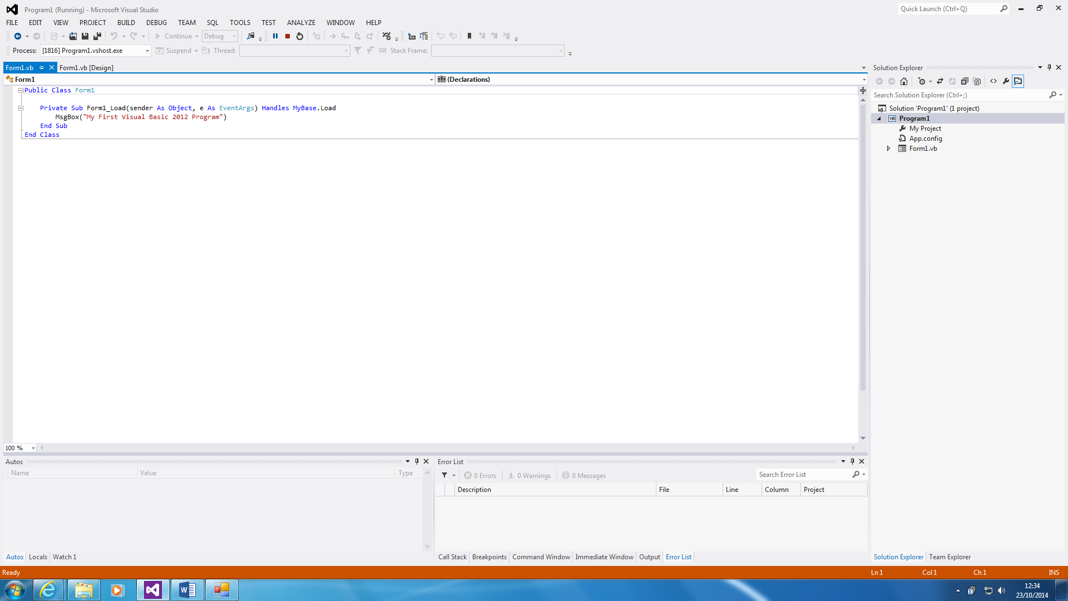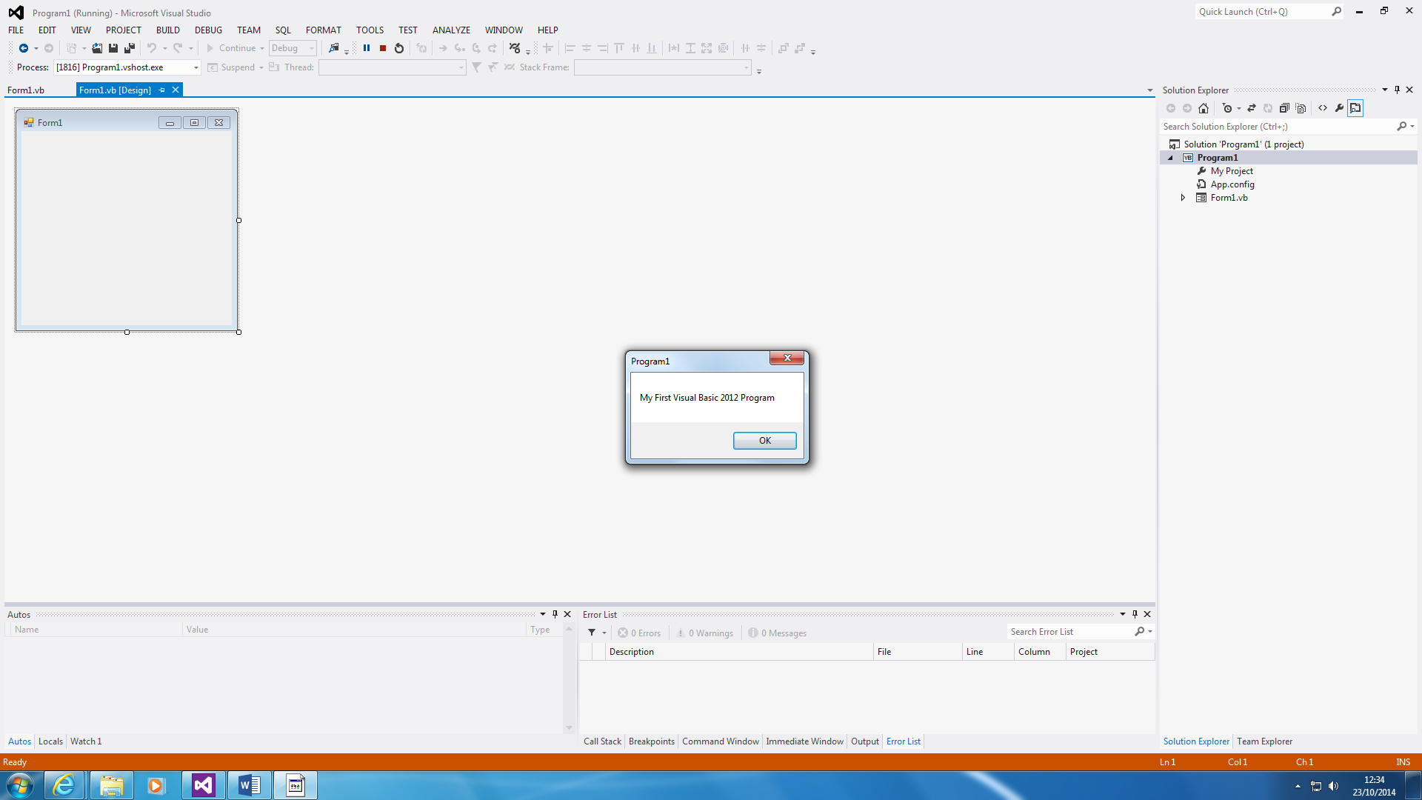

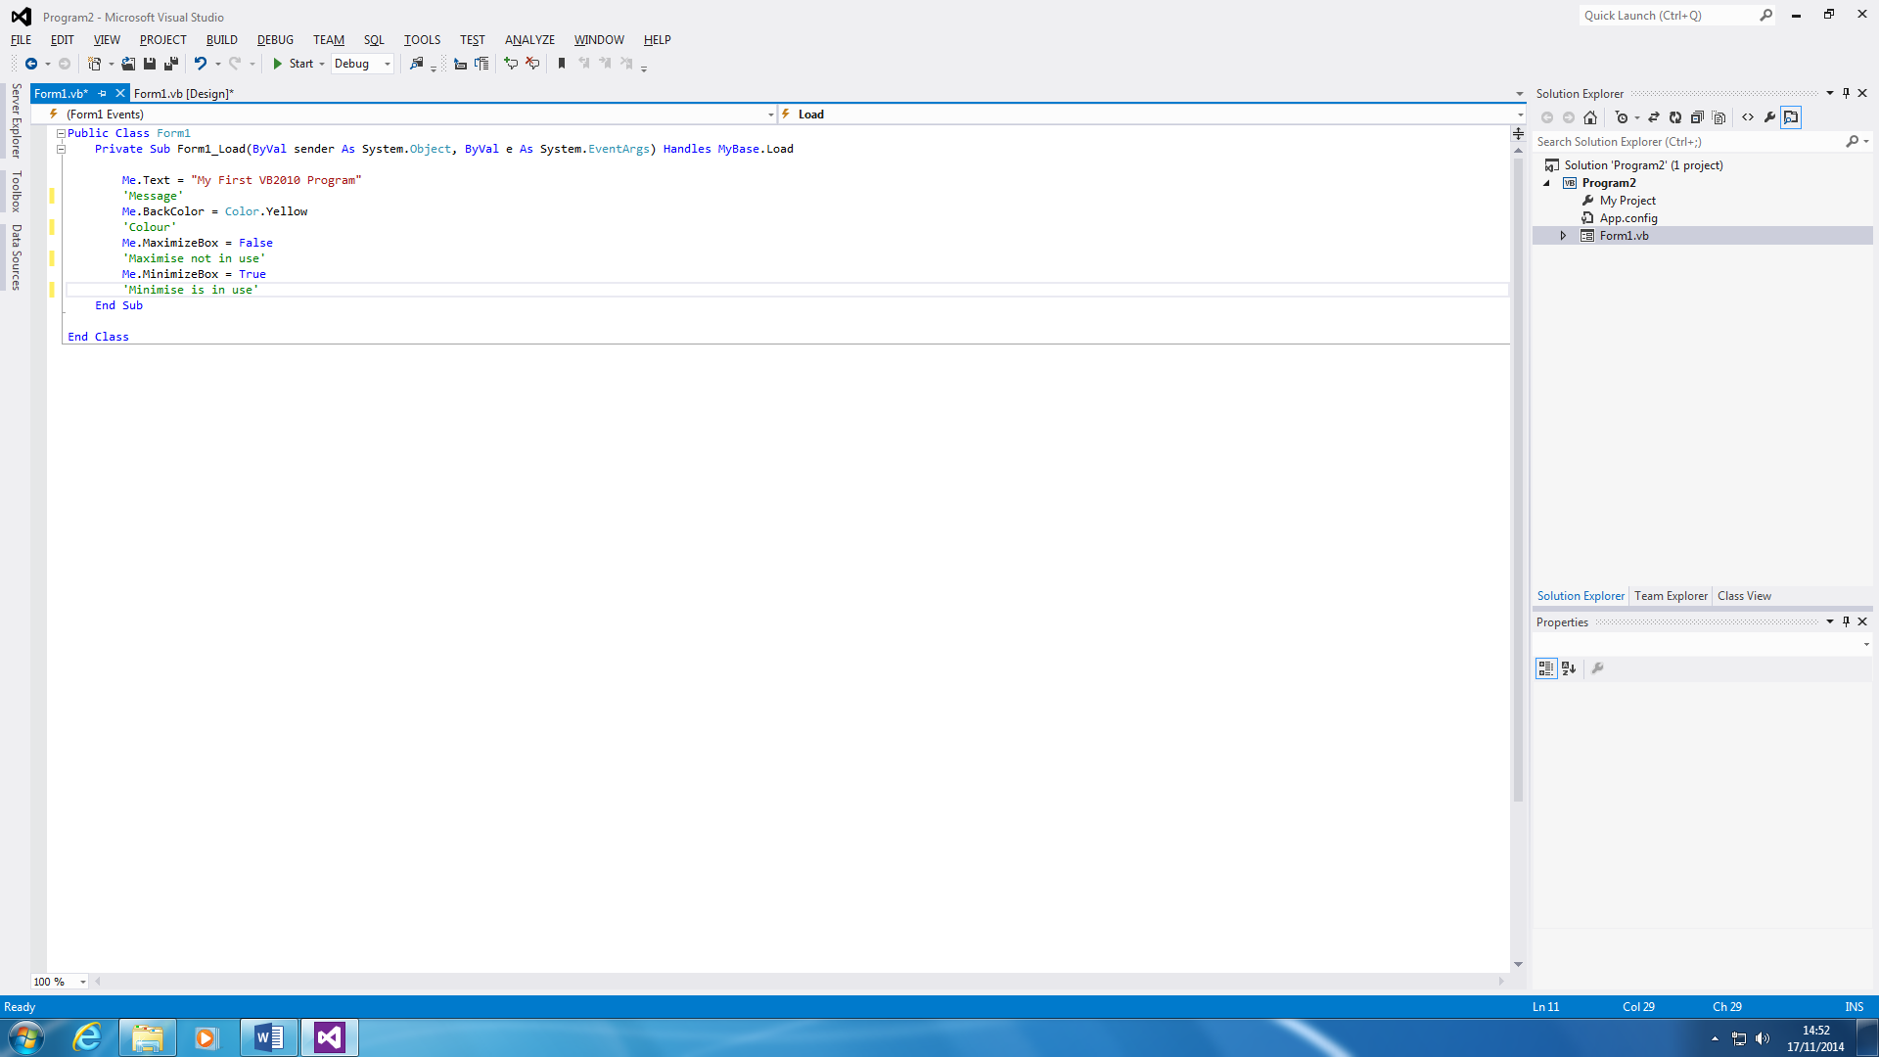**Program 2 – Background Colour**

Each program is designed for it to be different. Each line is designed to do different thing. The first line of the code only shows what it will say at the top of it. If you want to change it, you can whatever you want it to say between the speech marks. The second line shows the background colour. I put yellow, but you can change whatever colour you like. The both two bottoms lines are for to maximise the program and the last is to minimise. I put the maximum box false, to ensure that the user cannot enlarge the program using the maximum program. I put the minimise true for the program to minimise.

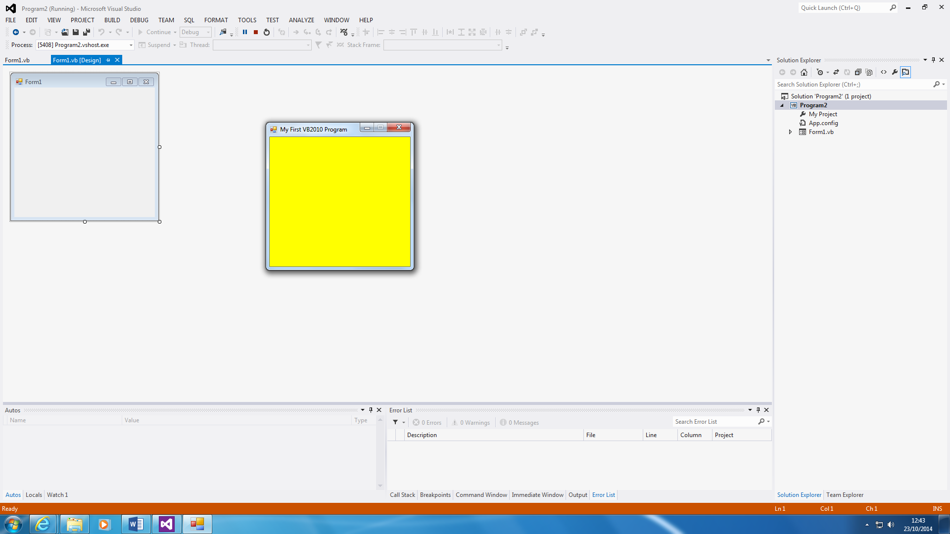

This is how the program has been presented. As you can see, the maximum button cannot be used at the start. You can use the mouse to minimise the program. The program only shows the colour yellow. I only done this, but you can make it to a lot more.

You can type in whatever you want in the message, but this once adds what I have typed in.

**Program 3 - Adding**

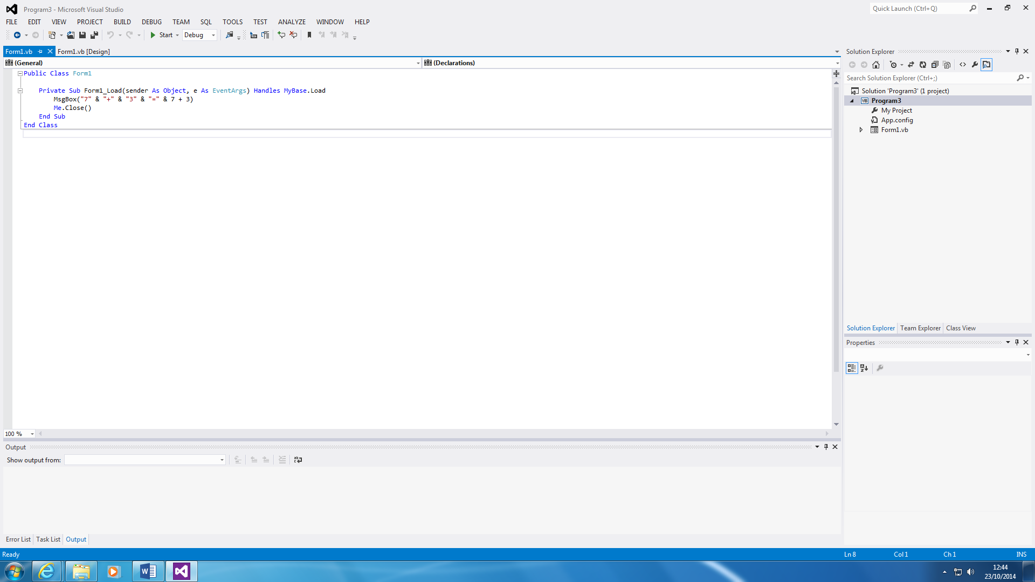

This closes the application. It closes the program, once the message has appeared.

This is another simple program that is made. This is the code of it; all it does is shows what 7+3 equals, and once that is done, it automatically closes. As you can see below, it equals 10.

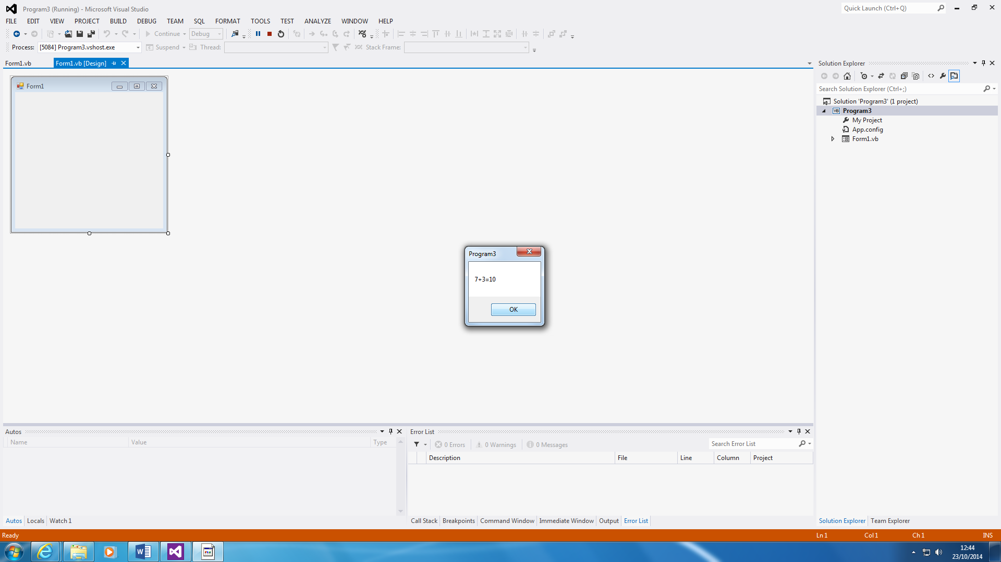

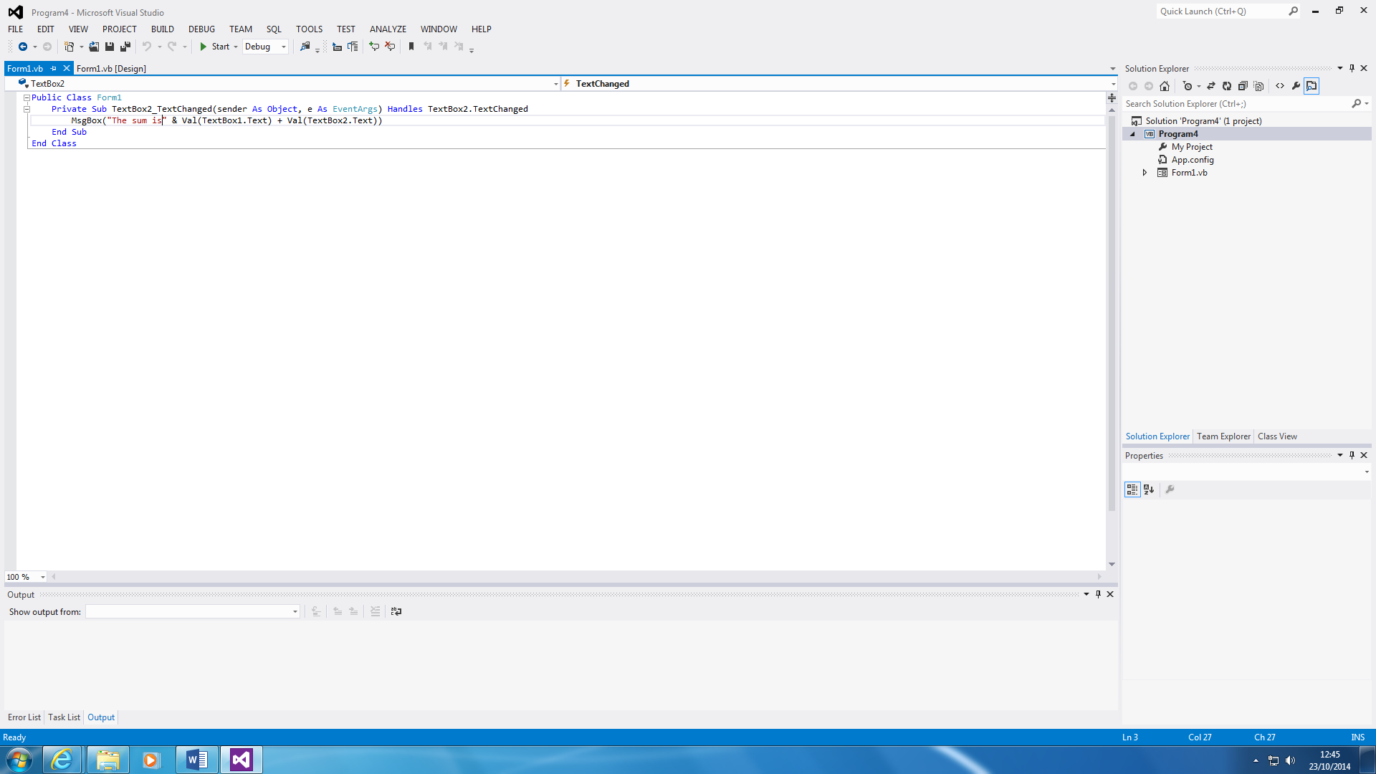**Program 4 – Add Calculator**

This is different from other programs that I have made so far. As you can see, the first code is to put up a message of what the following two textboxes is going to add together. Once both of the numbers are inserted, you click add and it is complete. You can change it to multiple, subtract, and divide by inserting it there.

An example of how the program works is shown below of how it works.

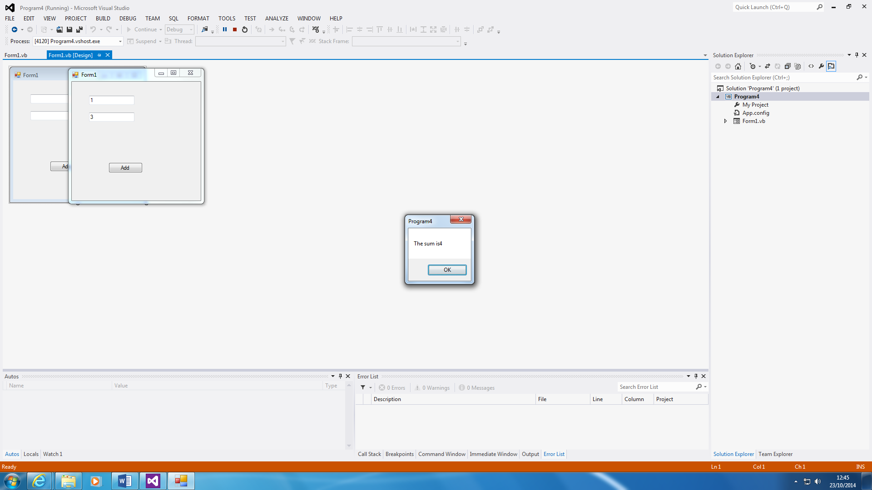

As you can see on the screenshots, the entered figures are 3+1 – which the user chose himself – and it equalled to four. Any figures can be inserted. All the program does is add the two numbers given together.

**Program 5 – Declaring Variables**

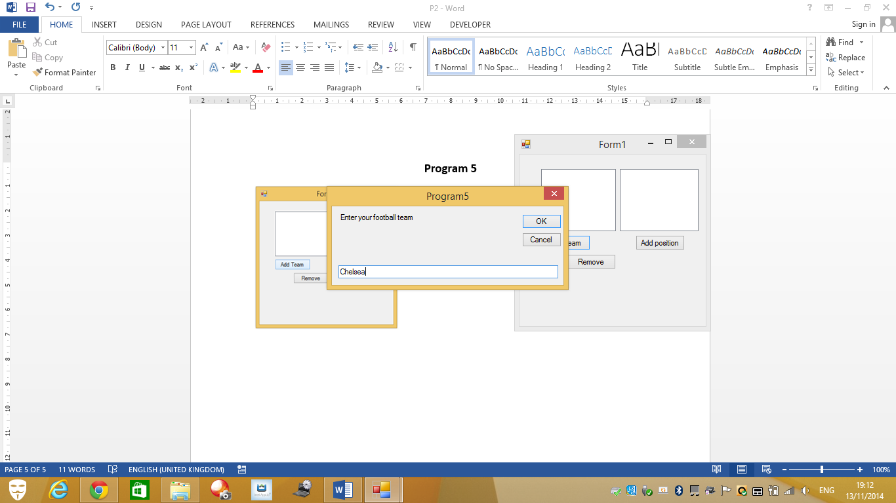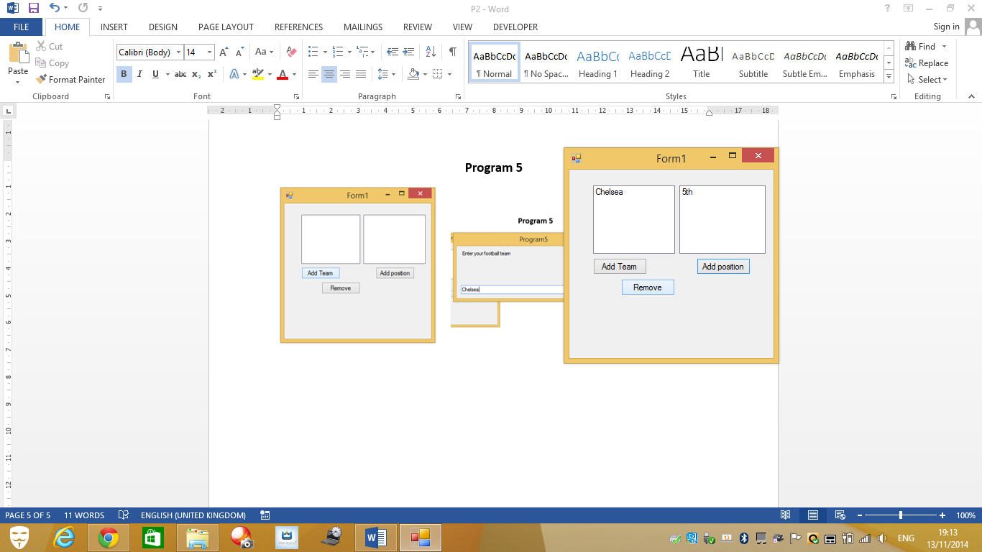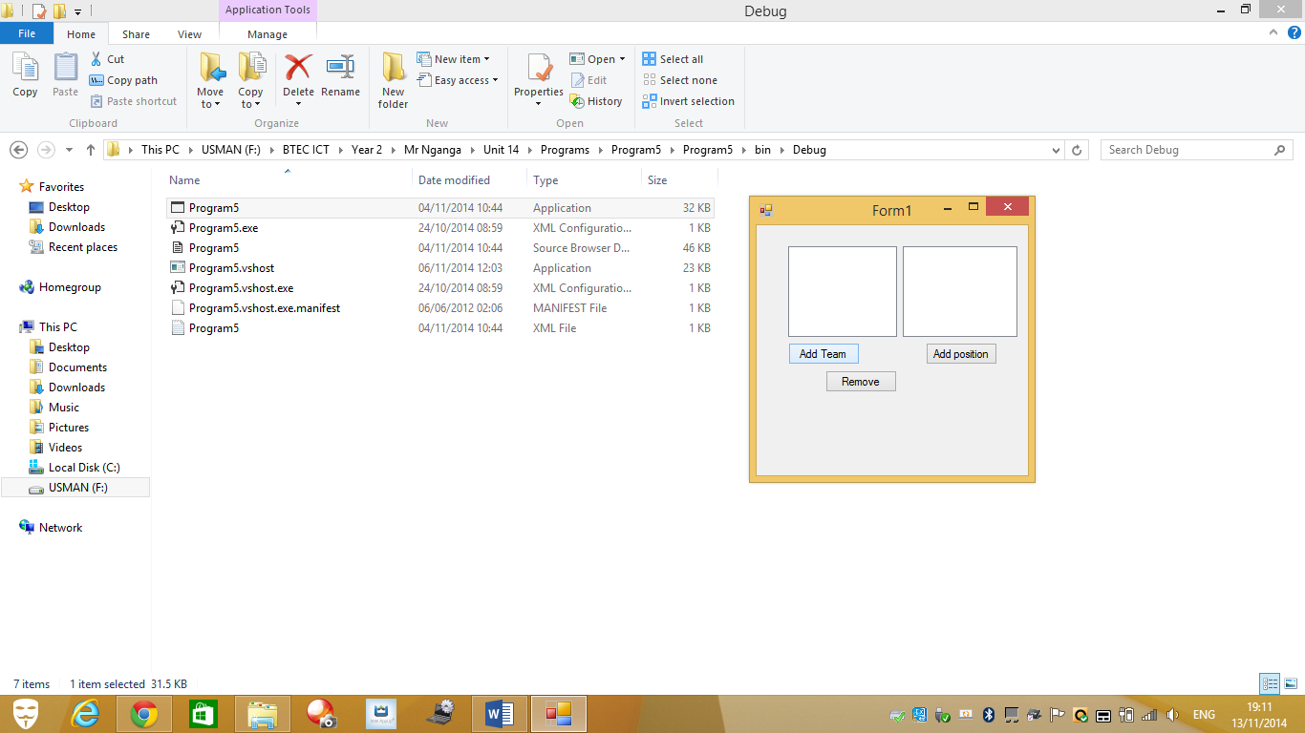

This program is different from others. It works as a ‘football-type’ one. All you do is add your team, and add its position. Chelsea are 5th is an example. It could work as a Premier League Table, but a bit different. You can remove it by clicking on the button, and it clears both of the ‘Team Table’ and ‘Position Table’.

The code below shows how I did it. Each of them represent different one.

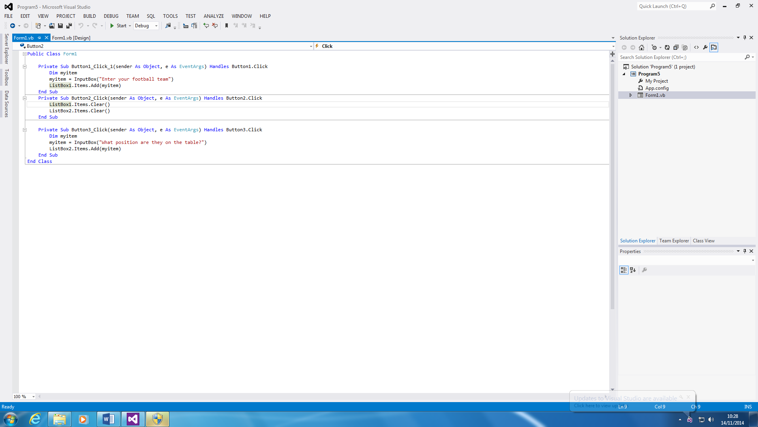

This is to clear both list boxes that are added from the toolbox.

This is the add position code that is needed. First I declared ‘myitems’ and this is what I can type into add position. Once I put it in, I put “What position are they on the table? This is used when the user is asked this question. They reply and it adds it to the second column of the program. This goes the same with the first code that I added. It follows the same procedure for the first list boxes.

**Program 6 – Picture**

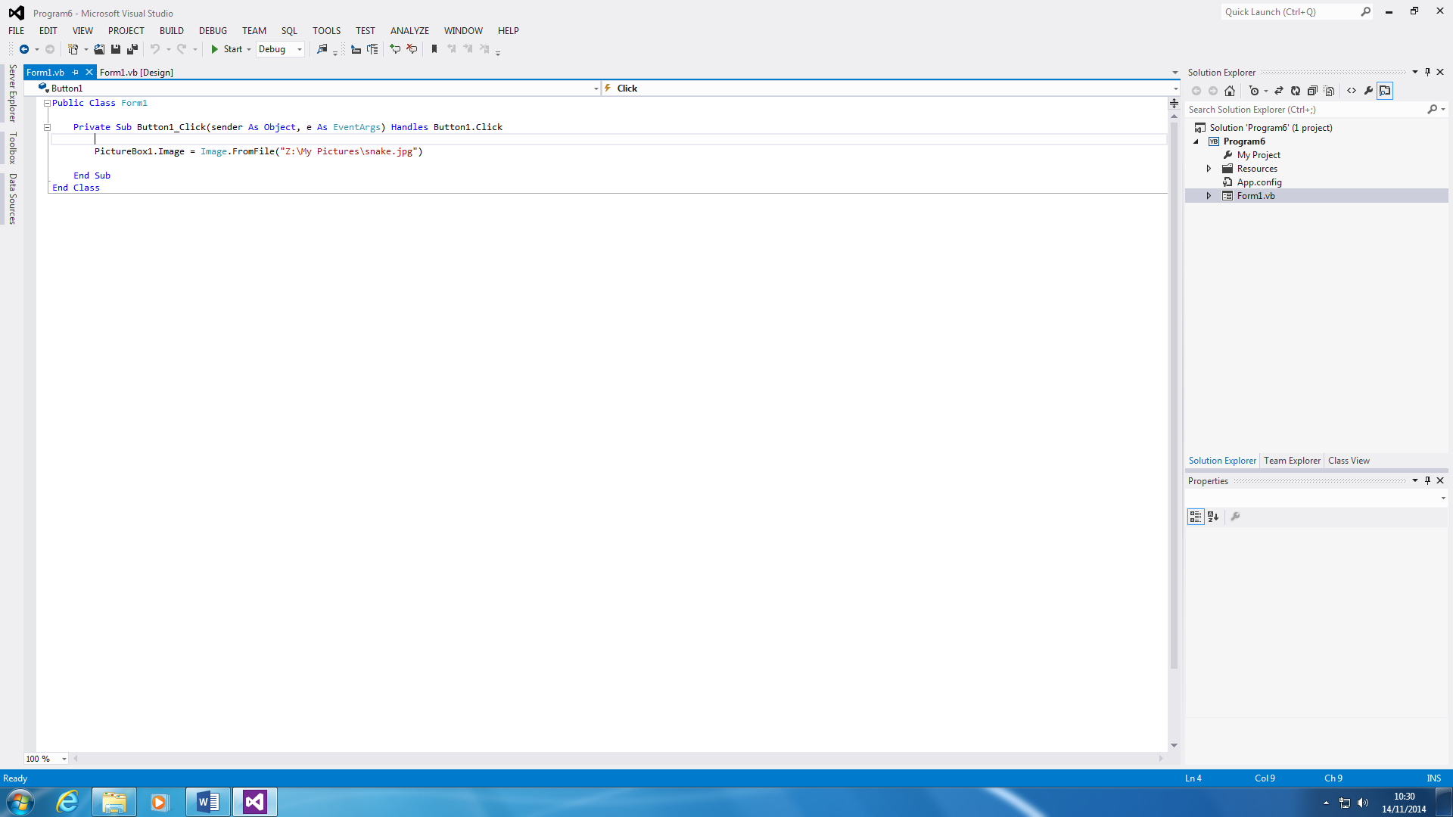

This program is simple, but different from other programs that I have made so far. The program is programed to get the file from the file that I have saved, and it shows it. This has to be linked to the specific hardware for the program to work.

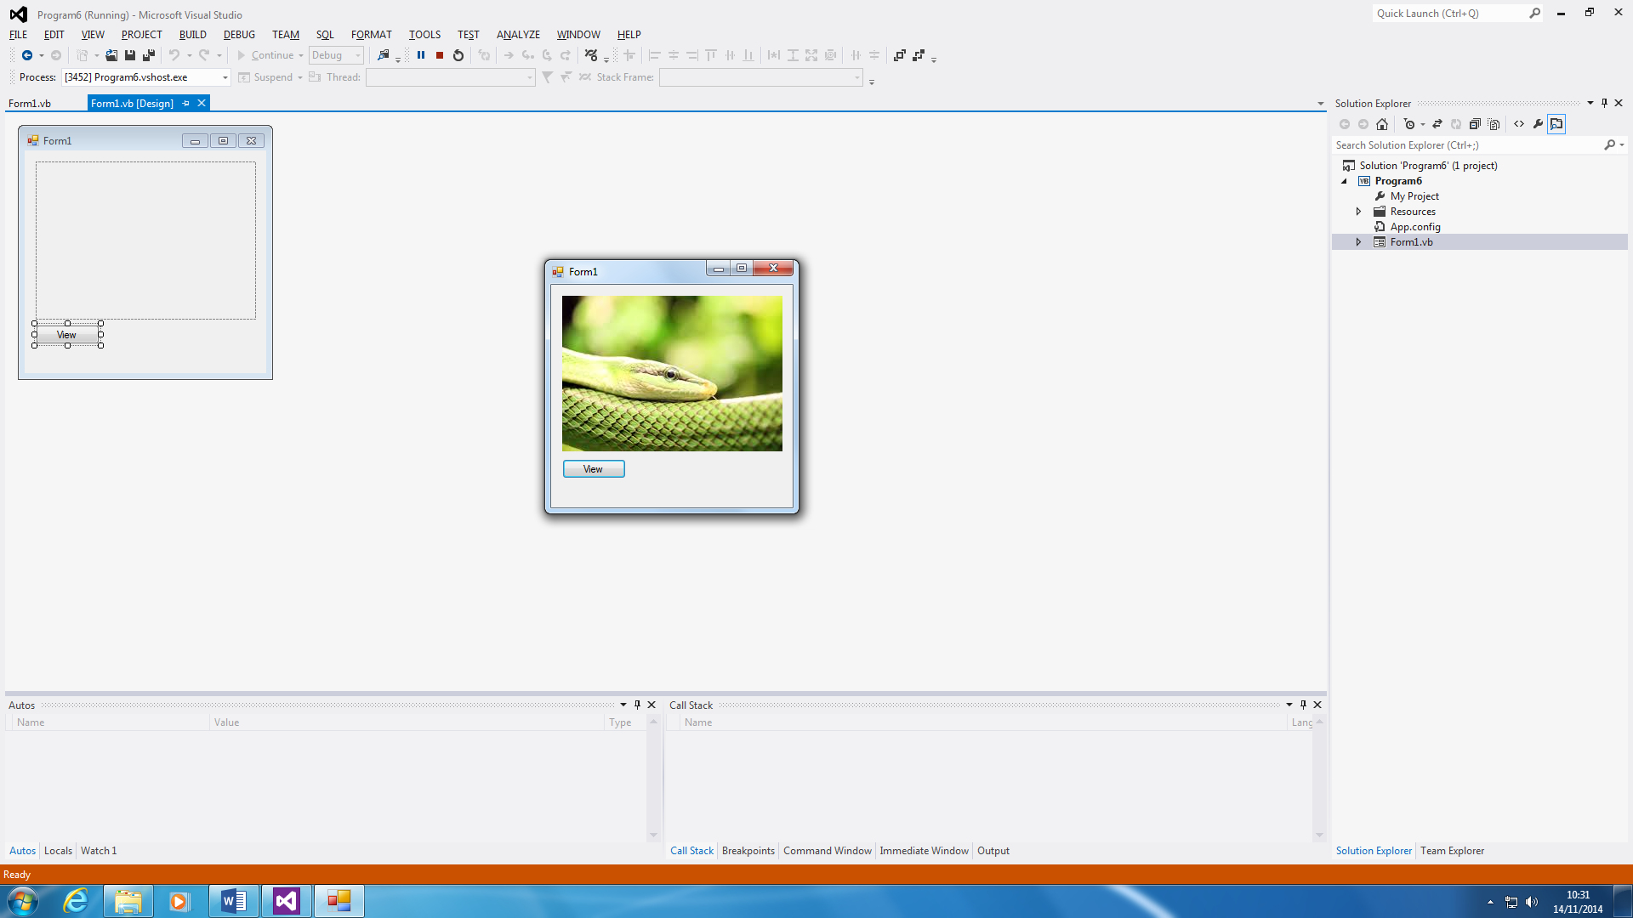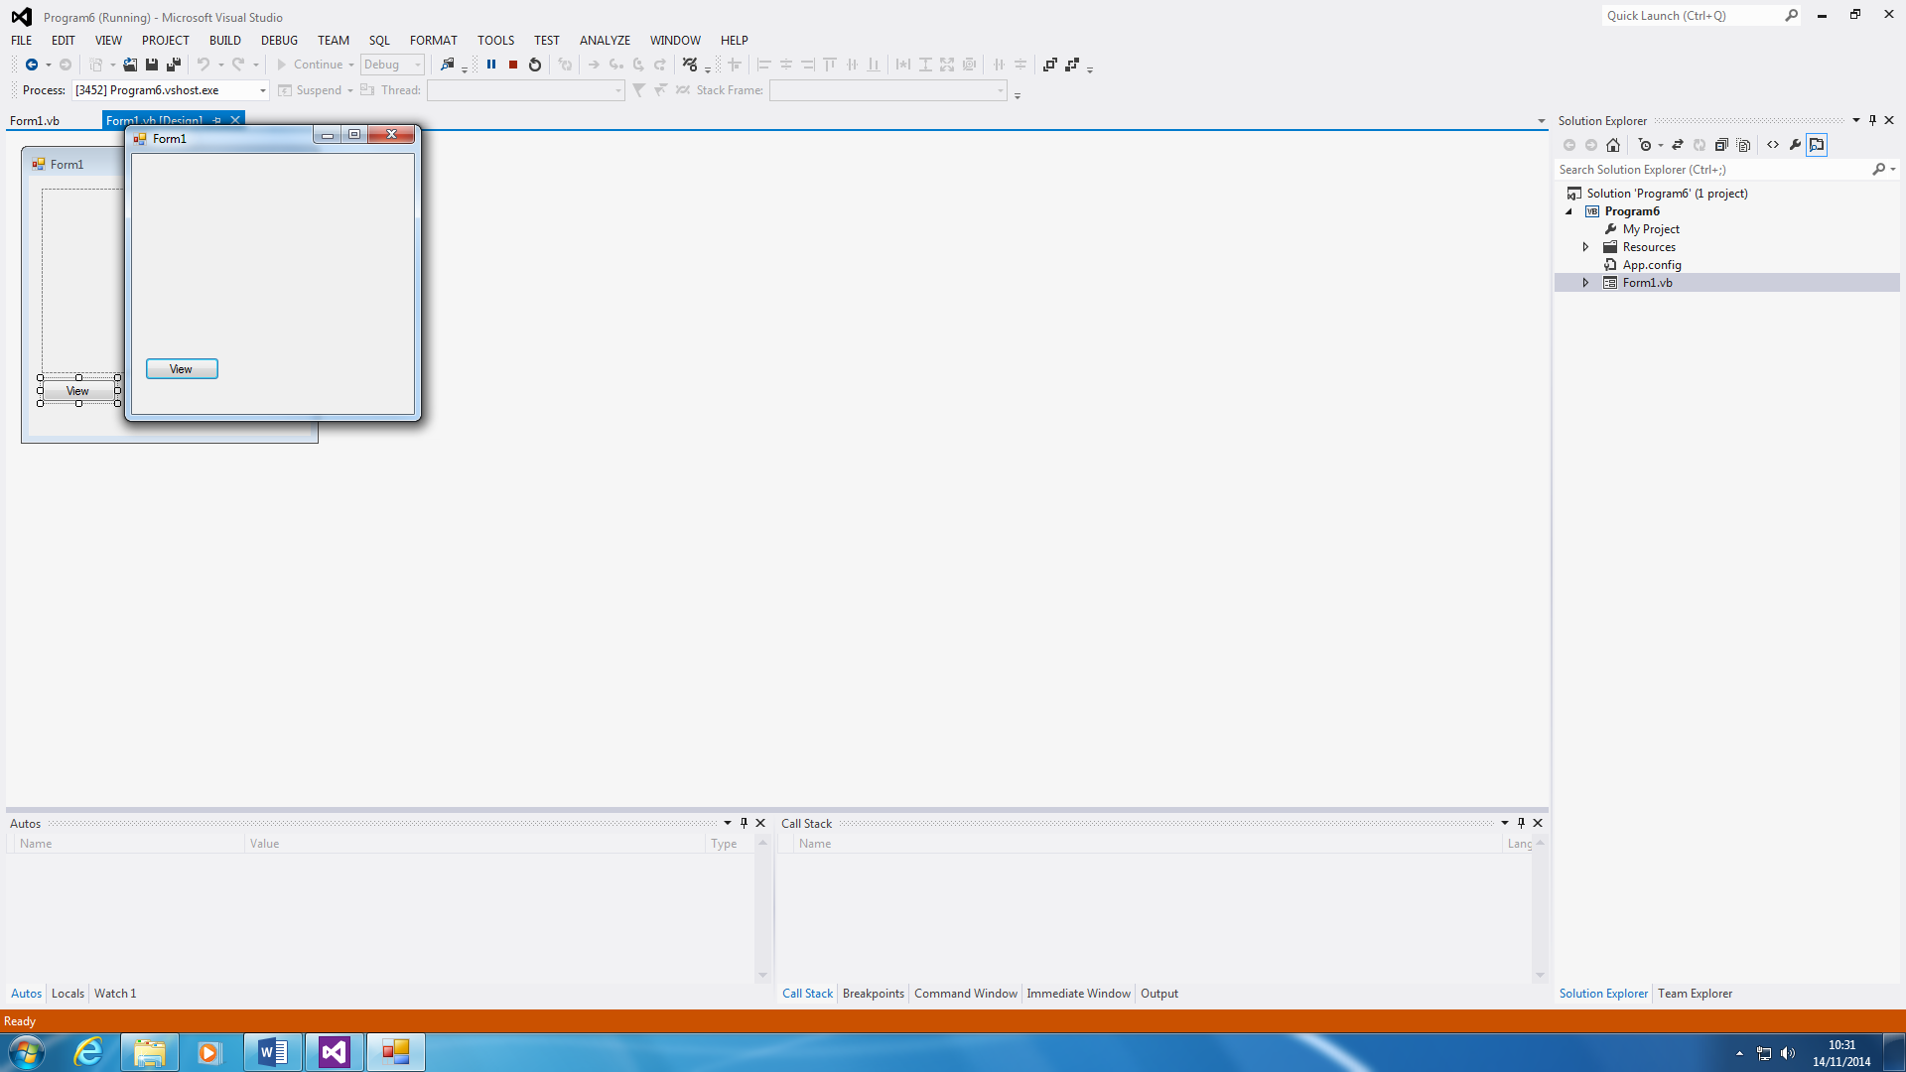

This is how it works. Once start is clicked, you see a blank screen except from a view button. To ‘view’ the snake image, you have to click on the button. This can come in handy when someone is making a retail website. You can programme it to do this for the website. For example, if a user has clicked on a jacket (online) they want, they can click on it, like this), press the view button and it would work. To make it more realistic, you can add a close button to close it

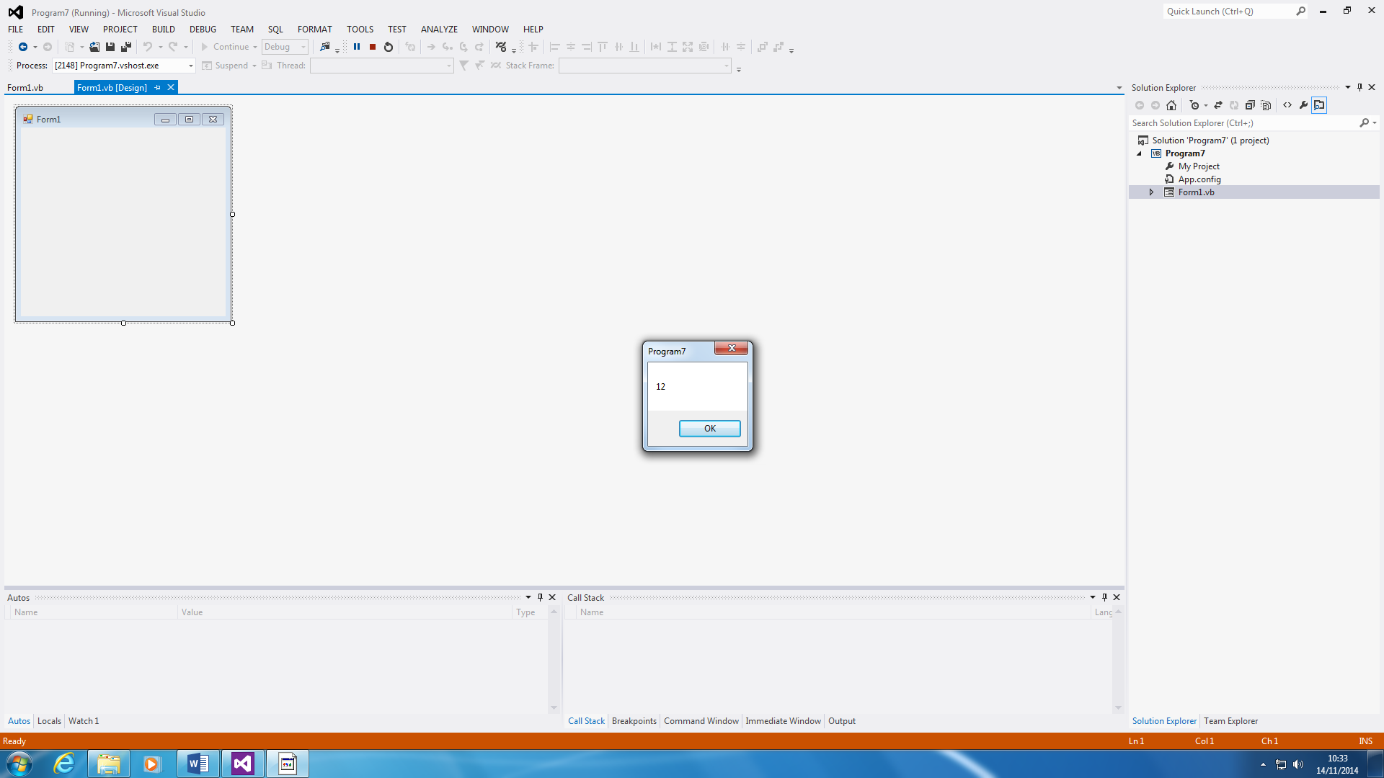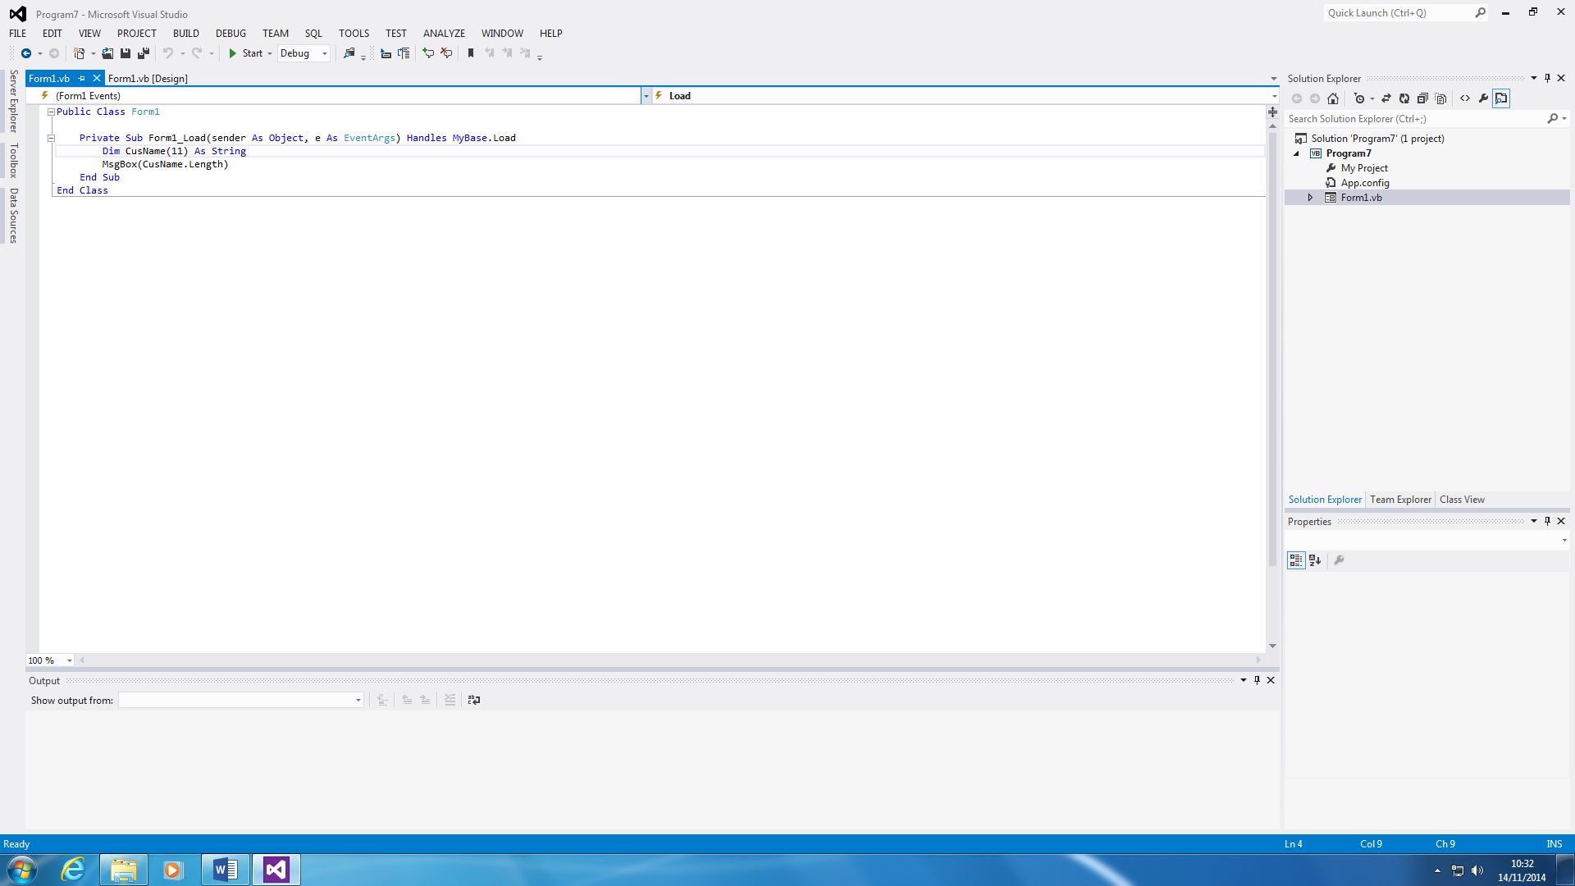**Program 7 – Arrays**

This is program ‘arrays’. This shows how Arrays work within Visual Basics. They are used, and both screenshots are shown for one dimension. They are multiple dimensions, but this is only shown for one. It is like finding out the ‘N’ number in Mathematics. For only this, you can use it as N+1. By me putting in 11, the answer obviously would be 12. They are harder ones then I have produced, but this is only a simple array.

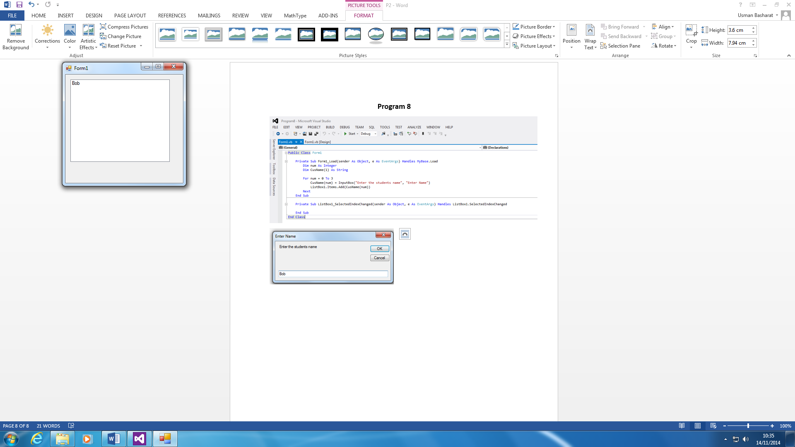

**Program 8 - Click**

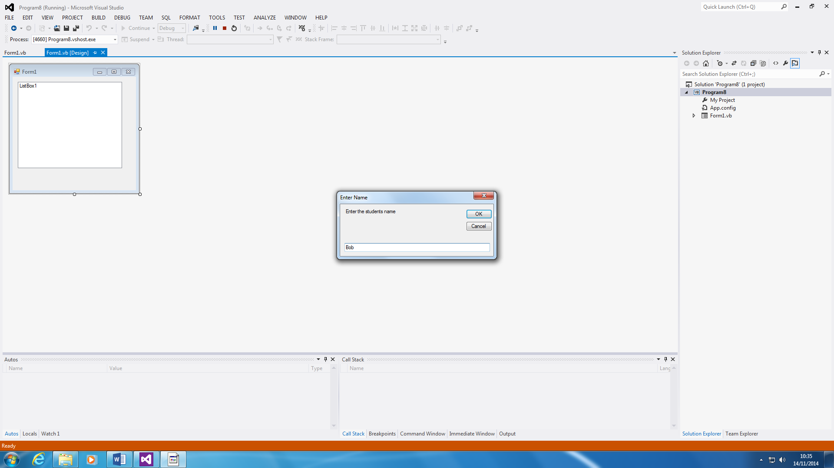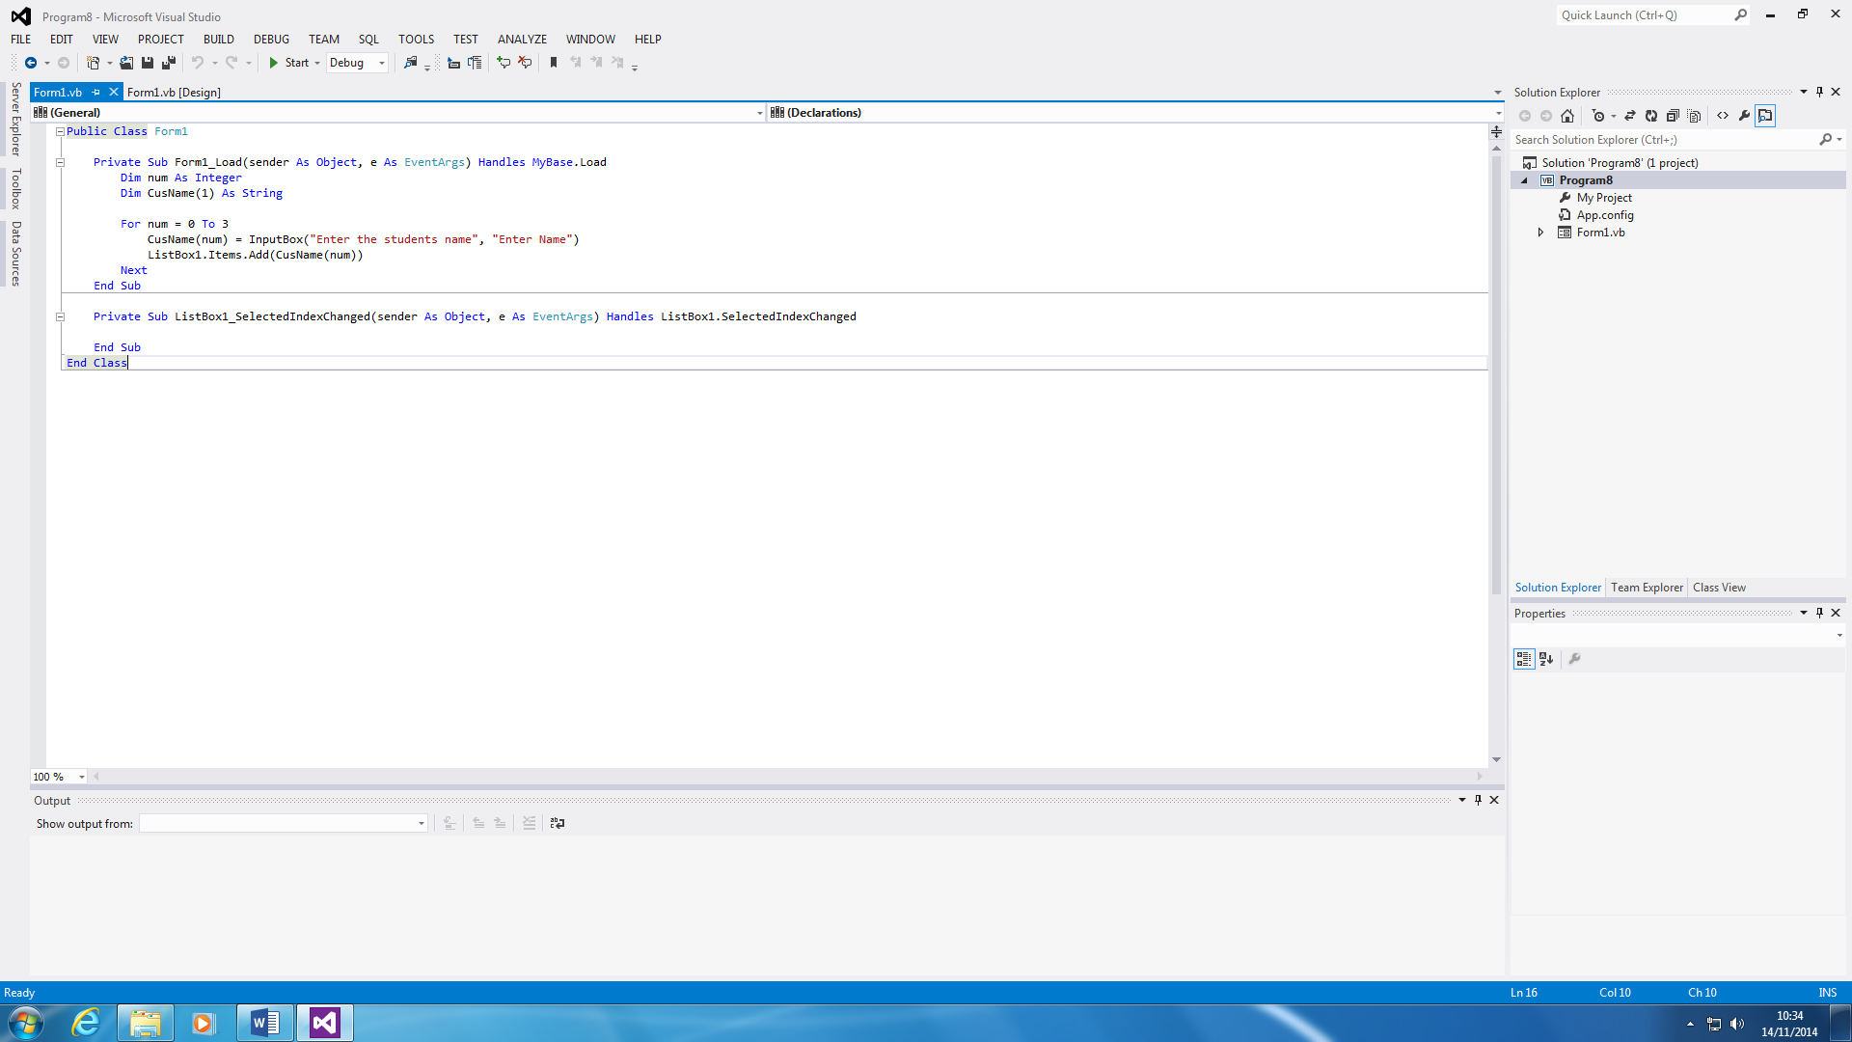

This is almost like a register. It is programed to put names within a list. ‘For num = 0 to 3’, this tells us that only you can enter the name three times. However, it will show on the board, only two names. It is a bit confusing the way it works, but you can extend the number from zero to 31, depending how many people are in your class, and use it as a register daily.

A screenshot shows how it works.

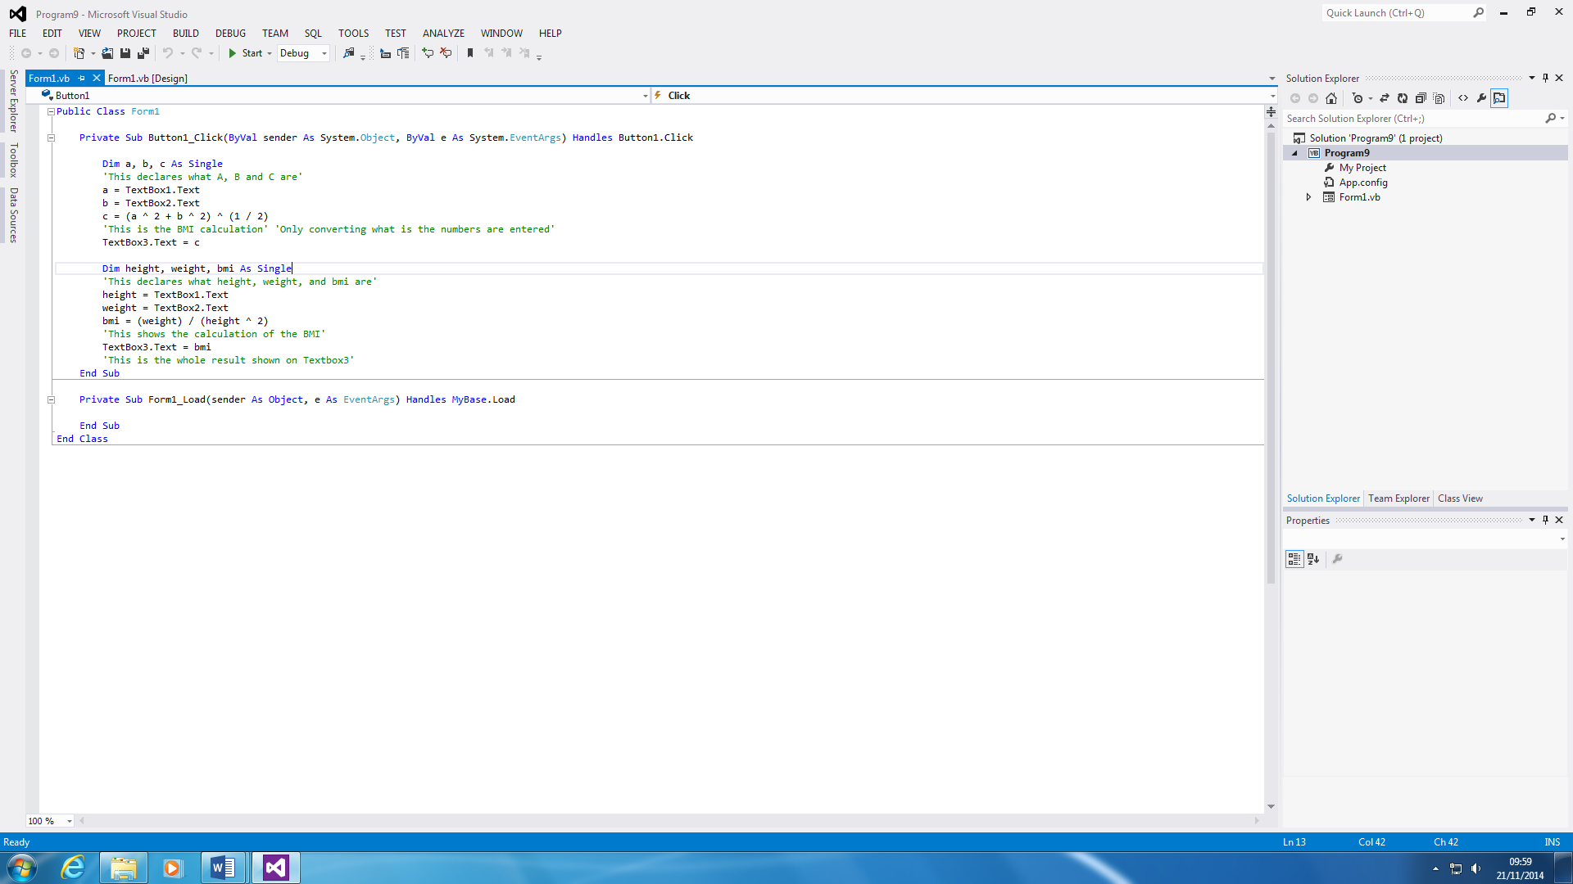**Program 9 – Calculator**

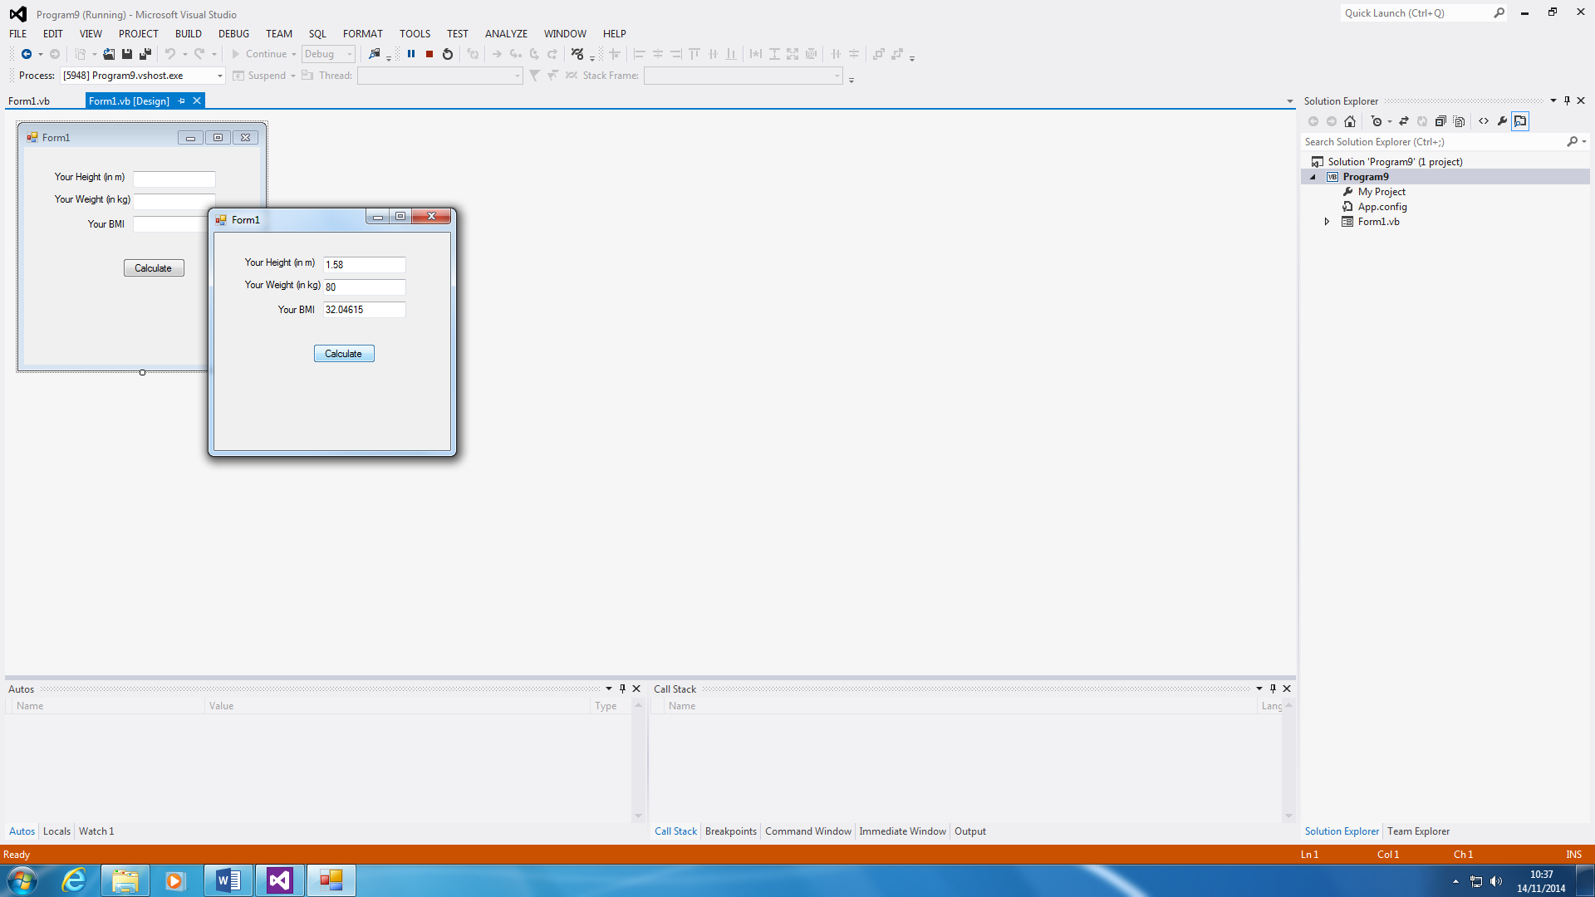

This is the BMI calculation. The purpose of using this program is to calculate a person’s BMI. If a person is 18 to 25, it is normal. If it is above or below, they are obese or underweight. All you do for this program is to enter the details of yourself as shown🡪.

It will calculate itself.

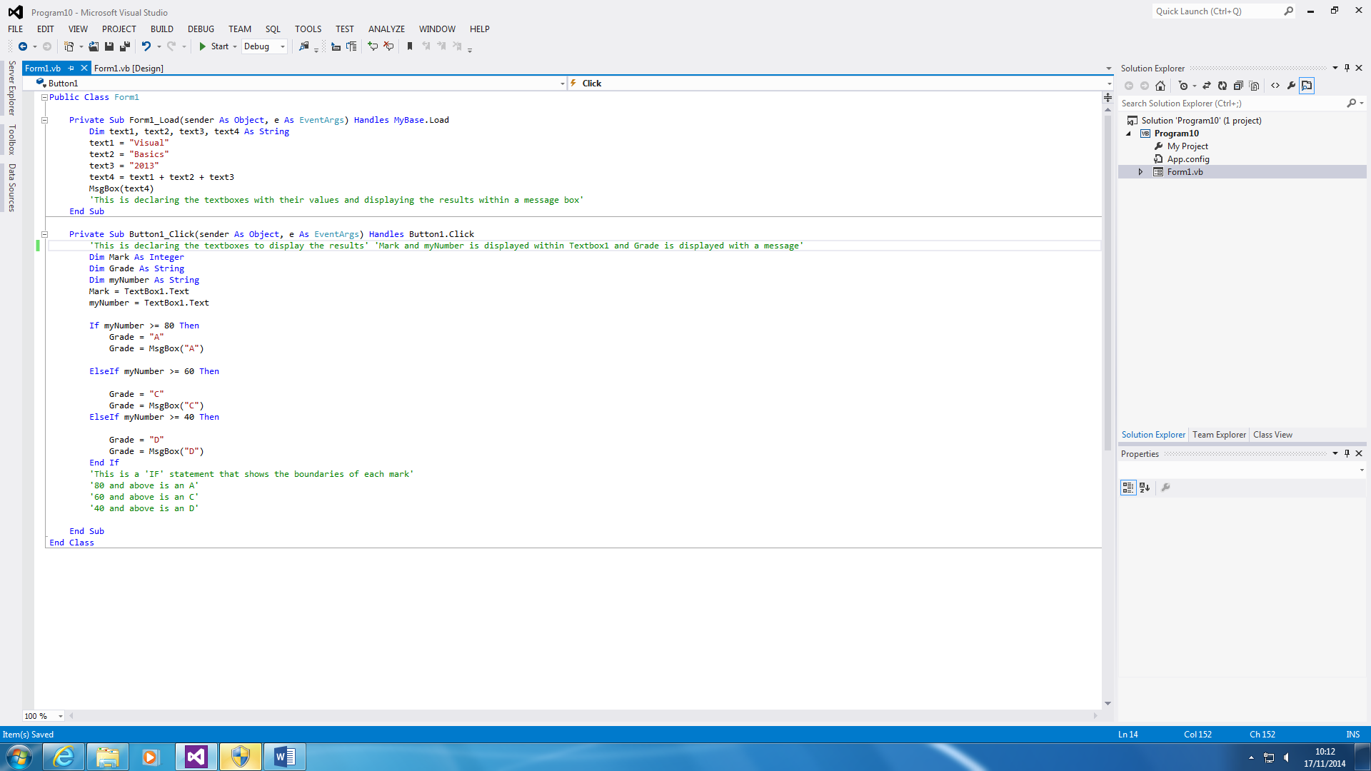**Program 10 – IF Statement**

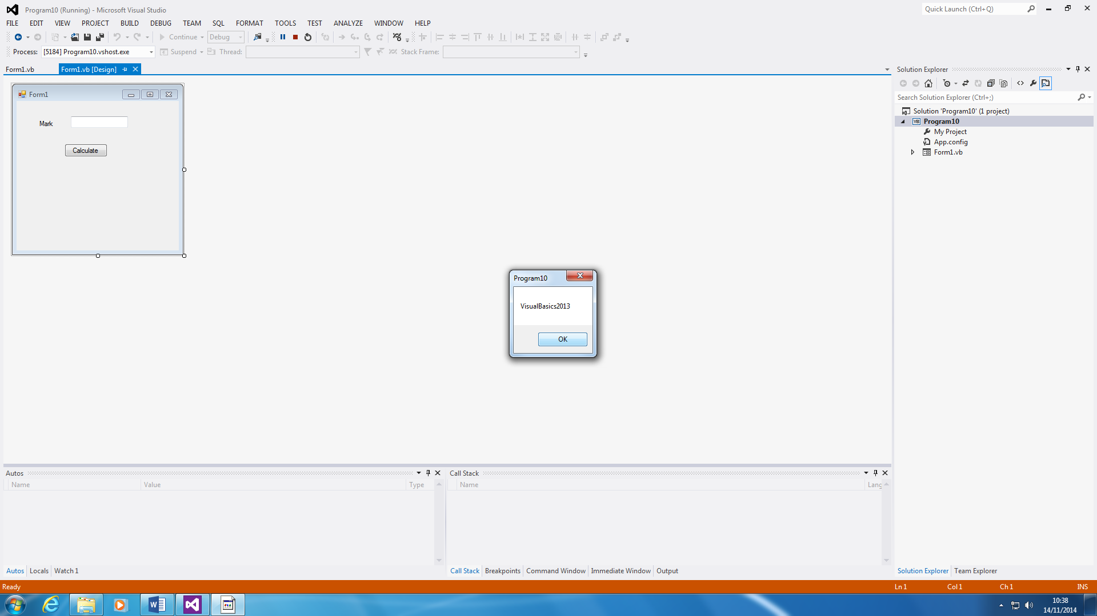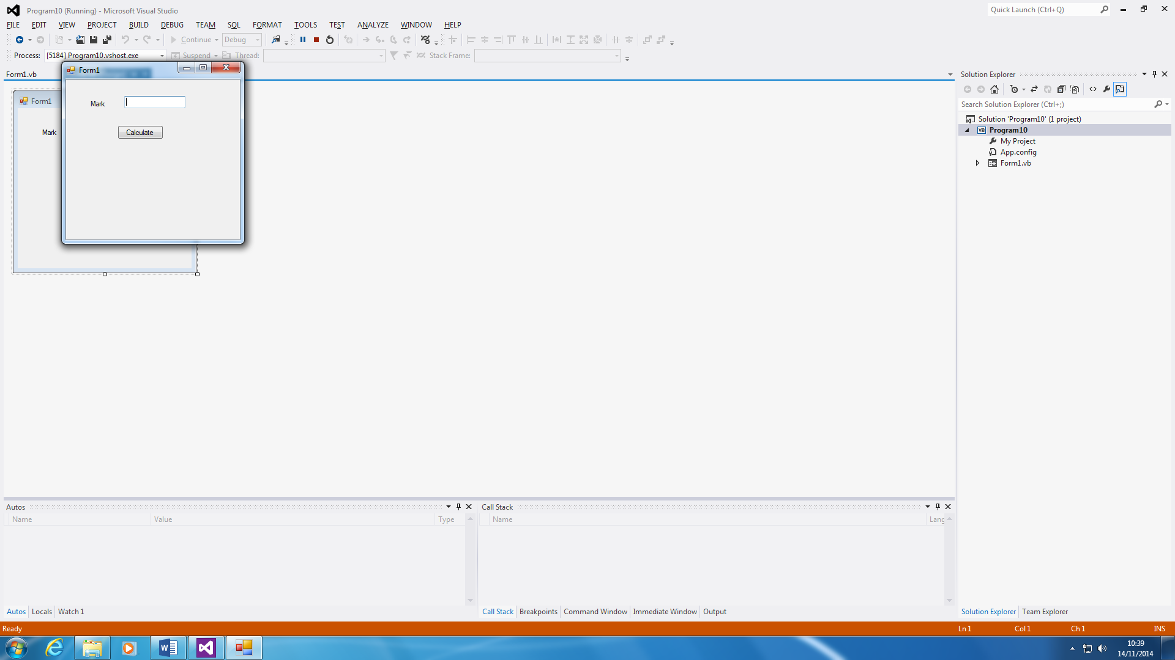

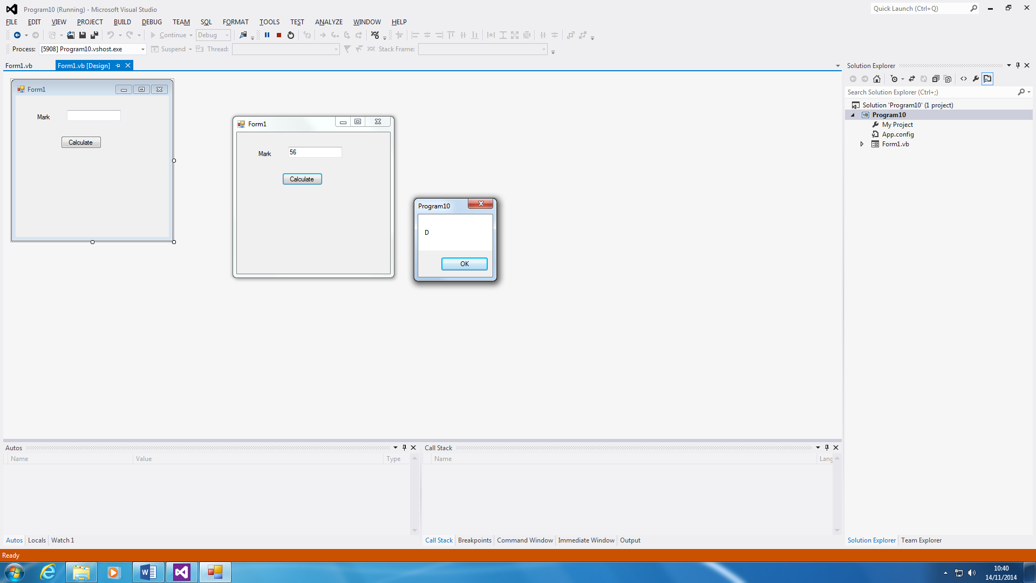

This program can be designed to calculate a grade for a specific paper. The grade boundaries are 80 and above is an A; 60 above is a C; and 40 above is a D. First, a message appears for VisualBasics2013, and then you put in your grade, as shown above. Whatever the mark is e.g. 56, it will grade it e.g. D.

**Program 11**

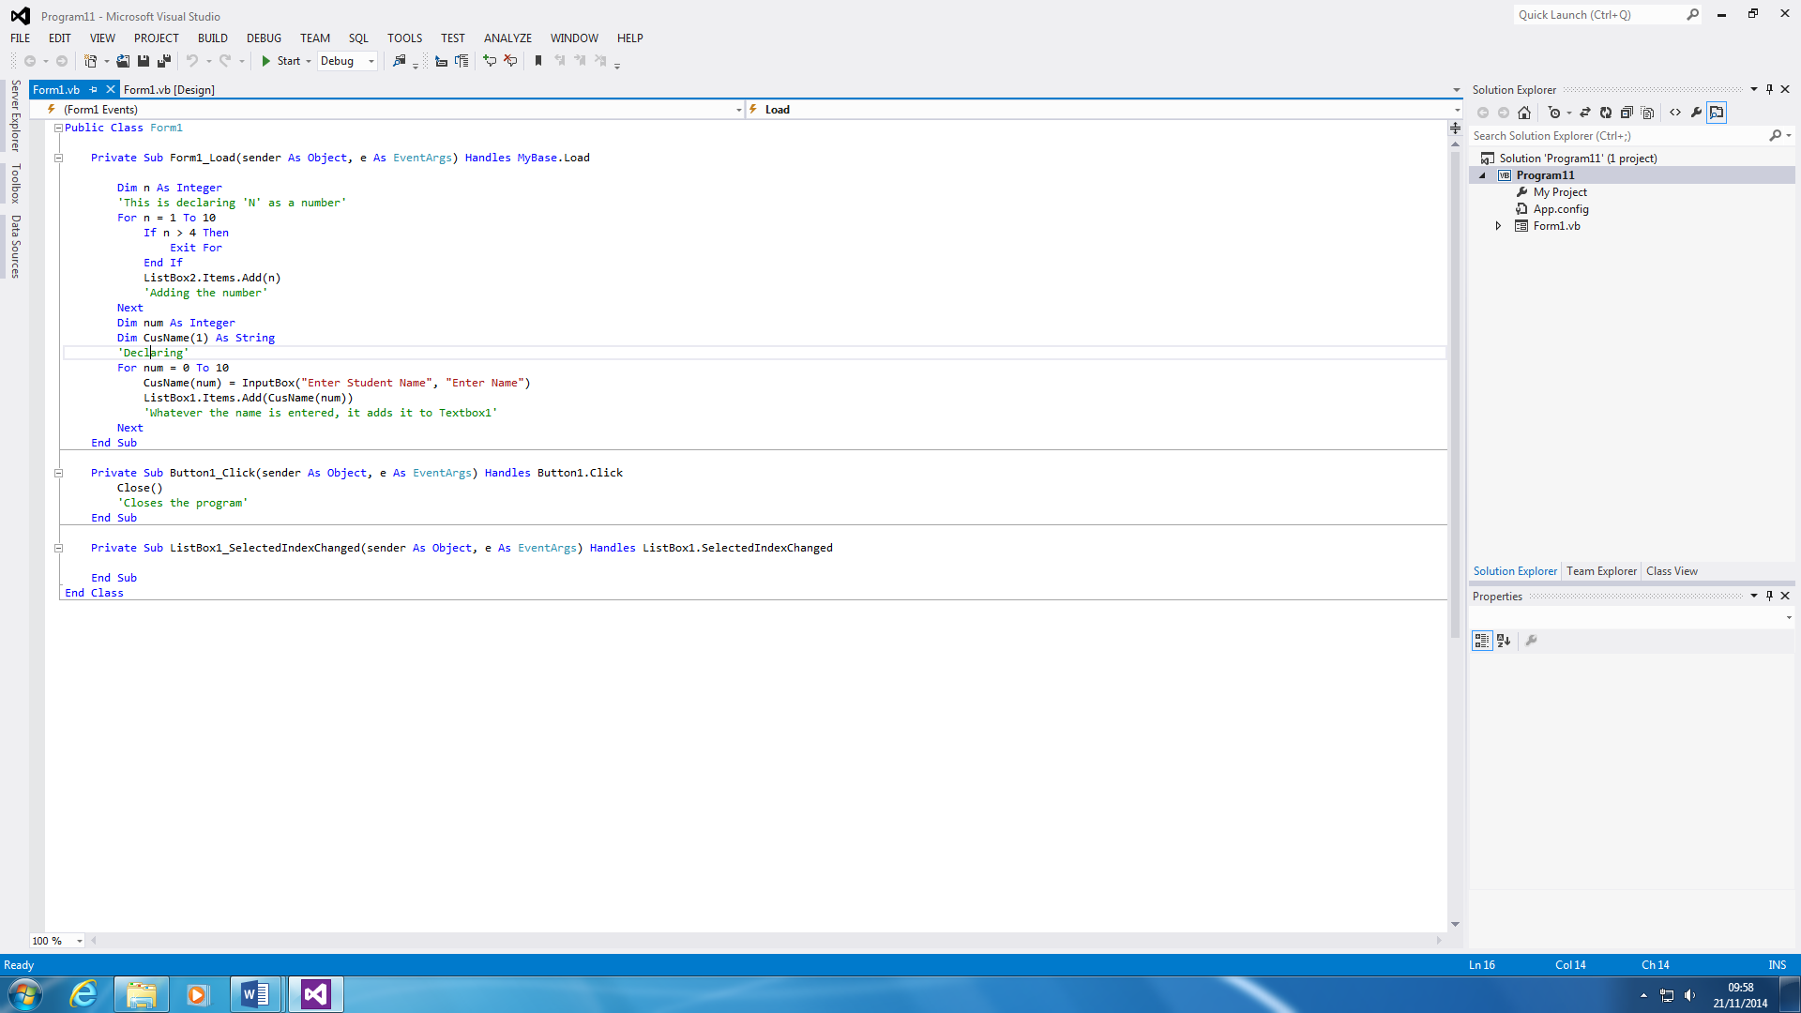

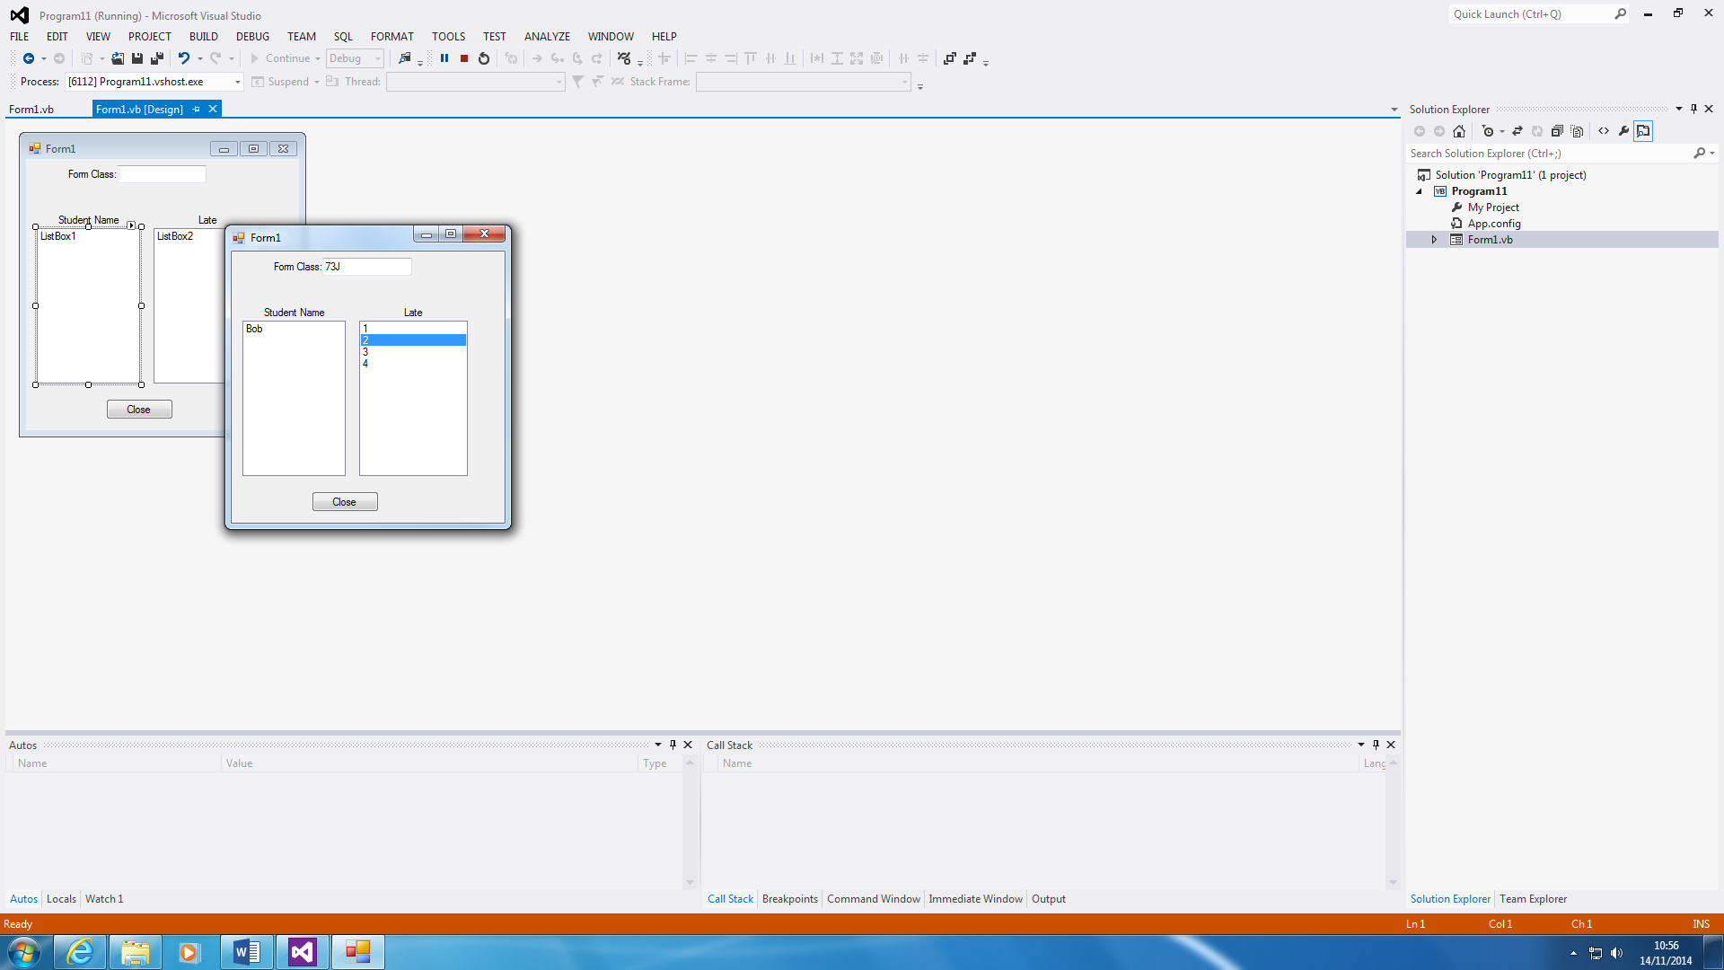

This program is very similar to a register. All you do is type in the student’s name and how many minutes he was late. It is only 1-4, because if students are above it, it cannot be accepted and they will be marked as absent. You enter which form it is in and you close the form.

**Program 12 – DO UNTIL and DO**

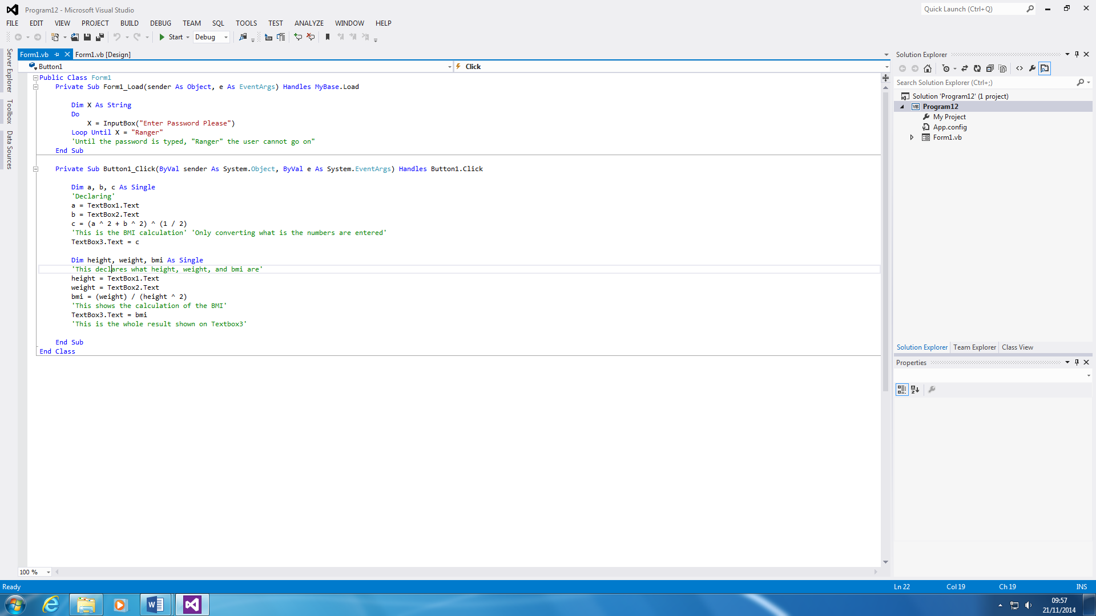

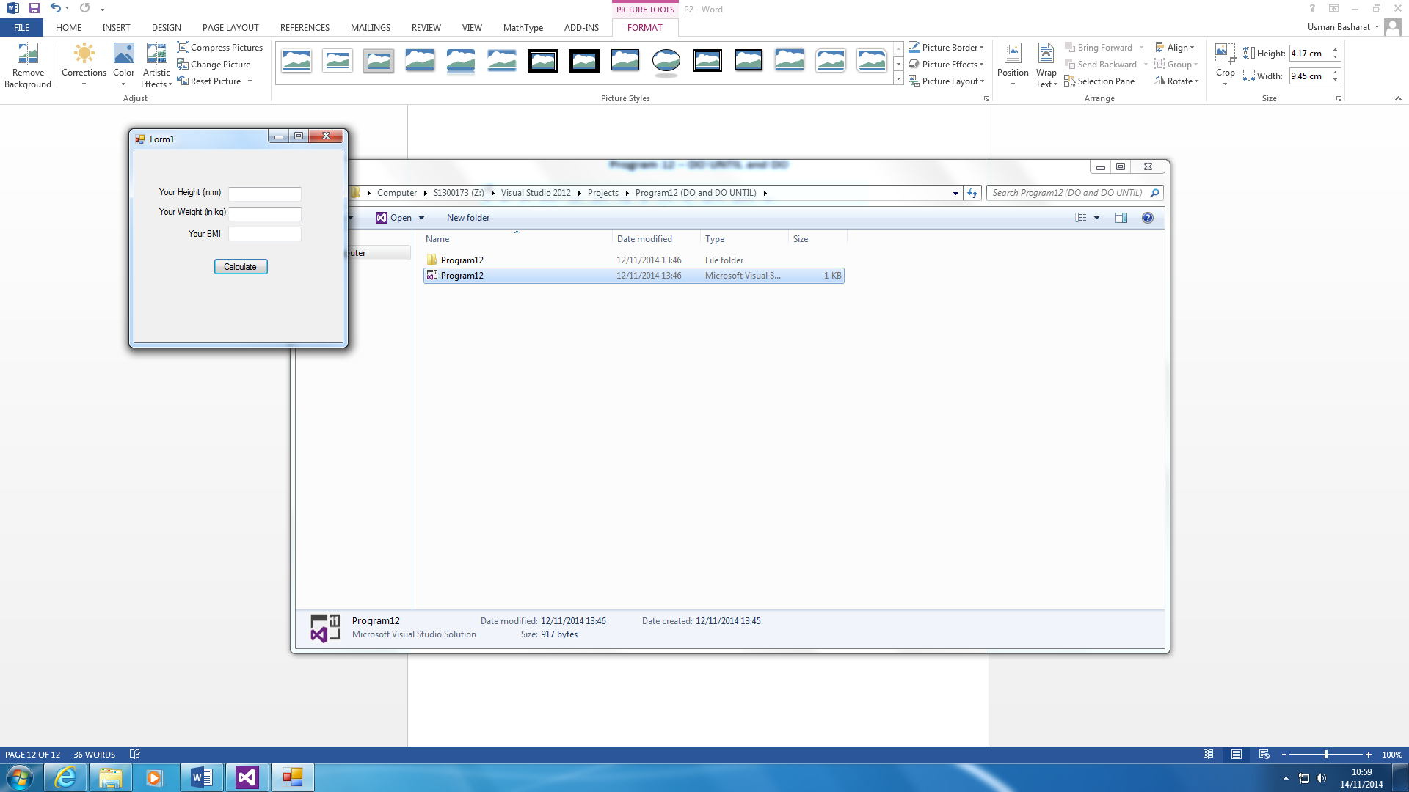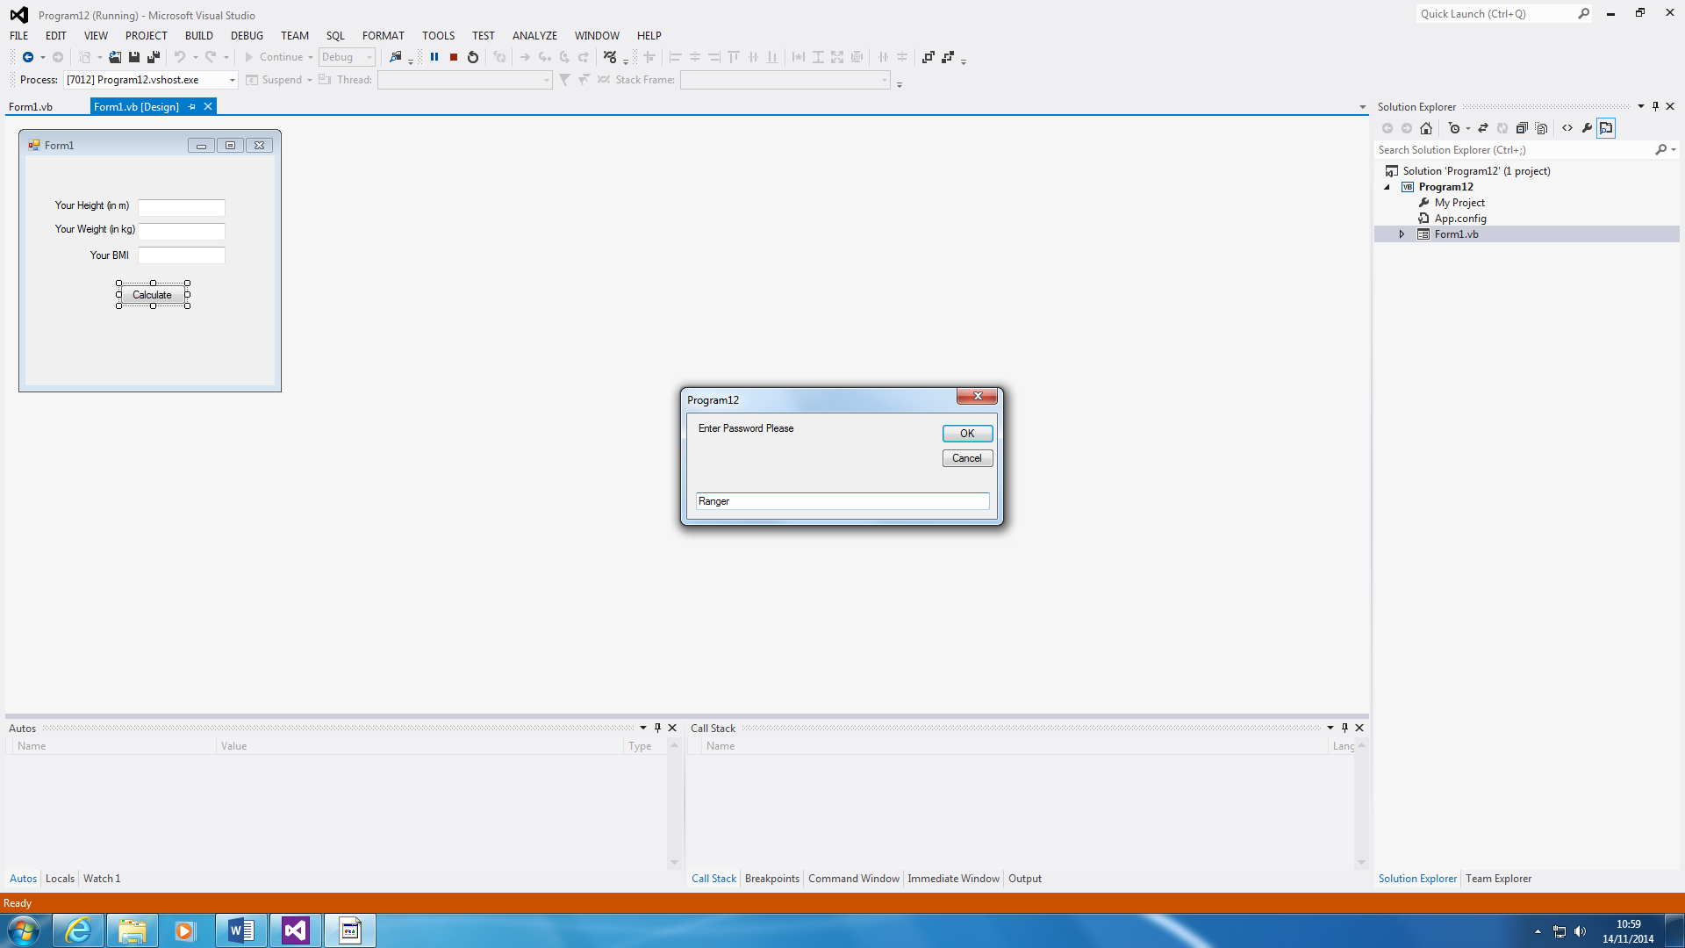

Before anything can happen, you have to type in the password. The main point of this is to keep a password. If the user wants to sign into something, you have to type in a password, until the user has entered it. The password is Ranger, and you can change it within the code.

It will keep repeating until the user has typed in the correct password.

This is the BMI calculation. The purpose of using this program is to calculate a person’s BMI. If a person is 18 to 25, it is normal. If it is above or below, they are obese or underweight. All you do for this program is to enter the details of yourself as shown🡪.

It will calculate itself.

**Program 13 – Key Press**

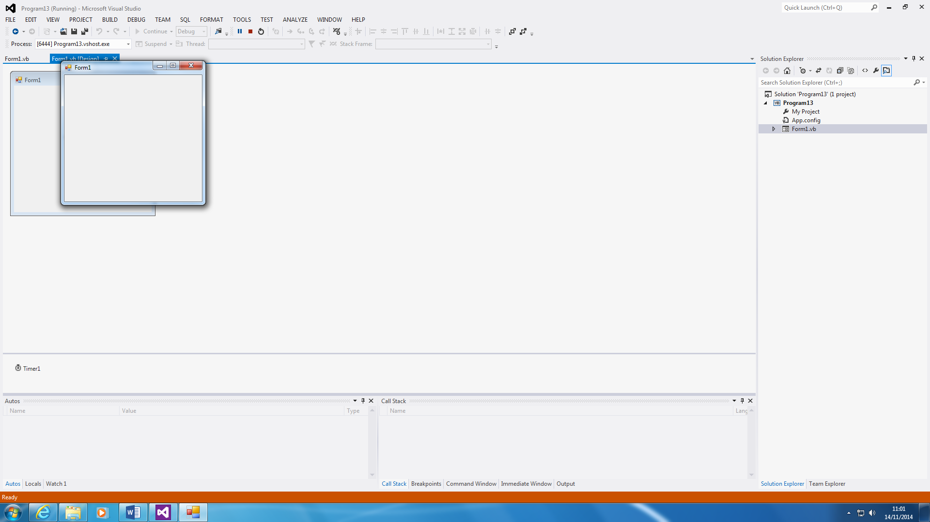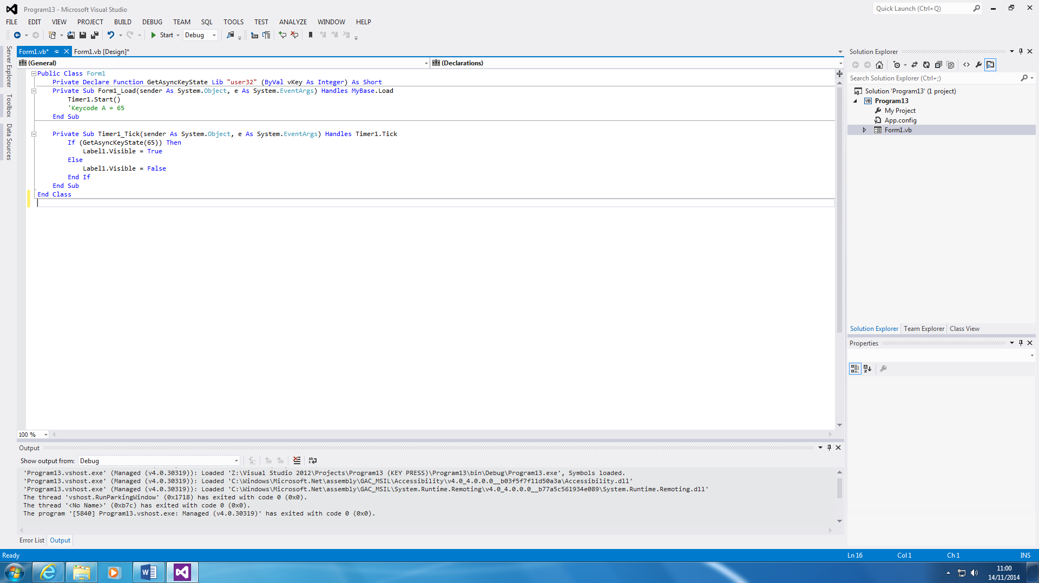

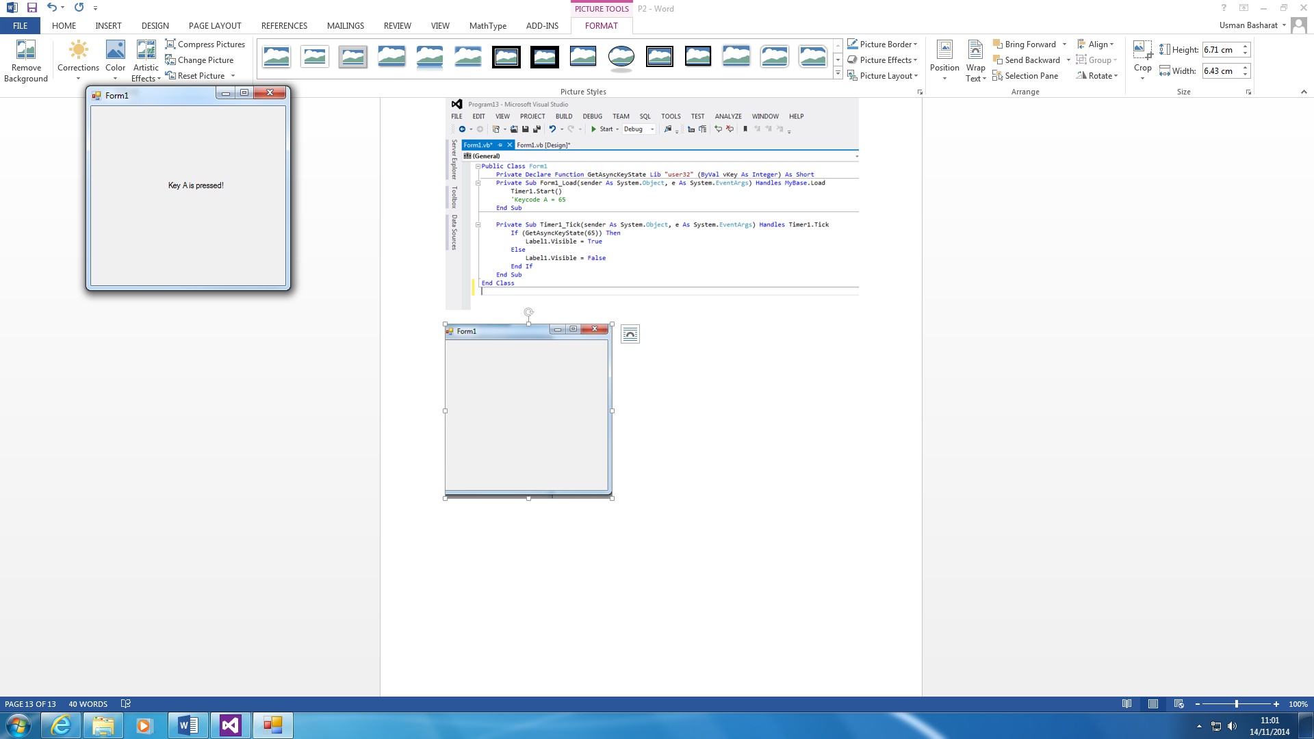

This program is very basic. All it does is it recognises that A is pressed. As soon as the key ‘A’ is pressed, a message will appear showing that it has been recognised. This message will not appear, until key ‘A’ is pressed.

**Program 14 – Declaring Constant**

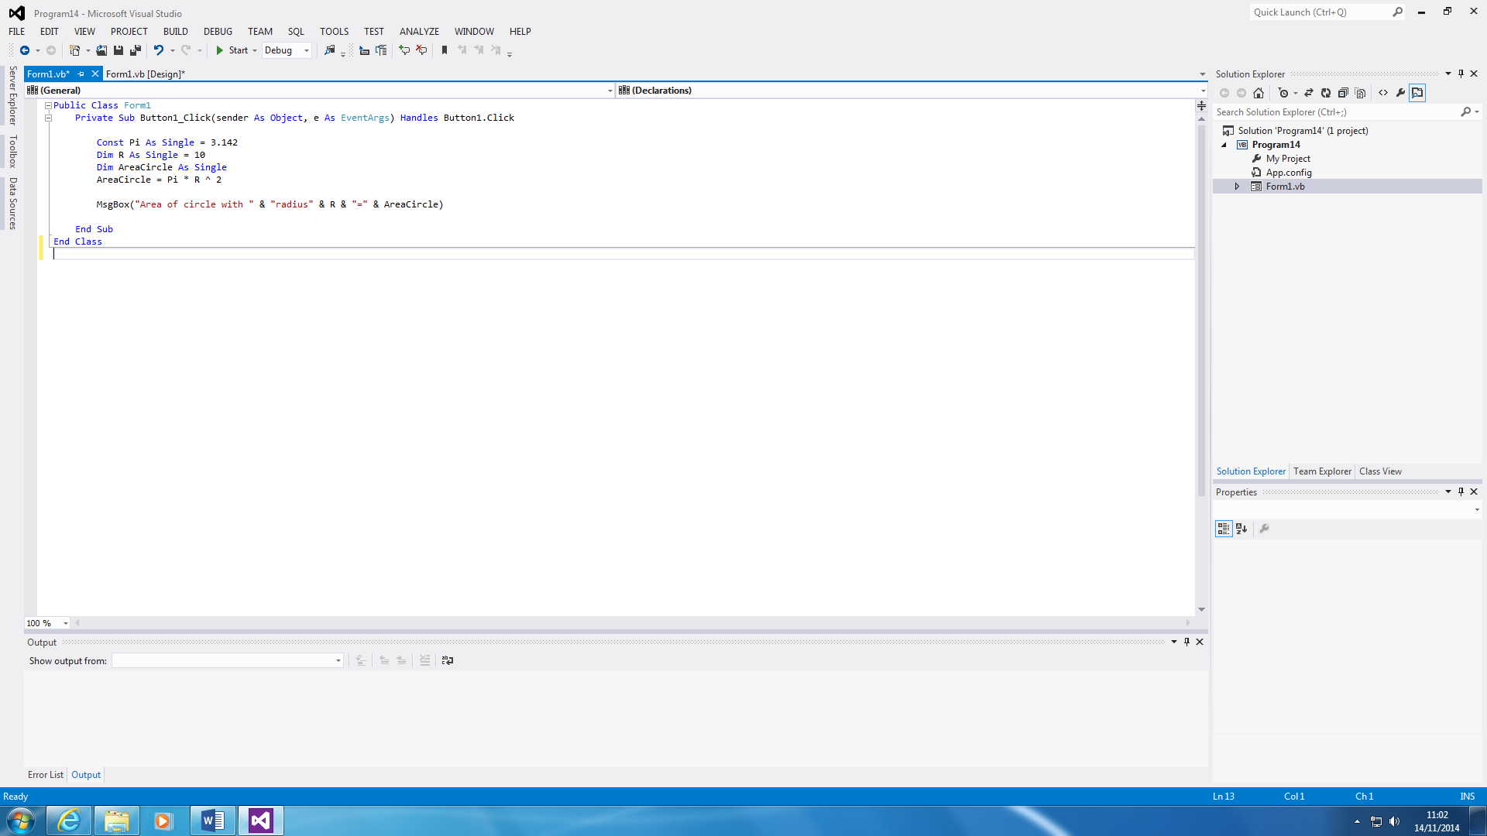

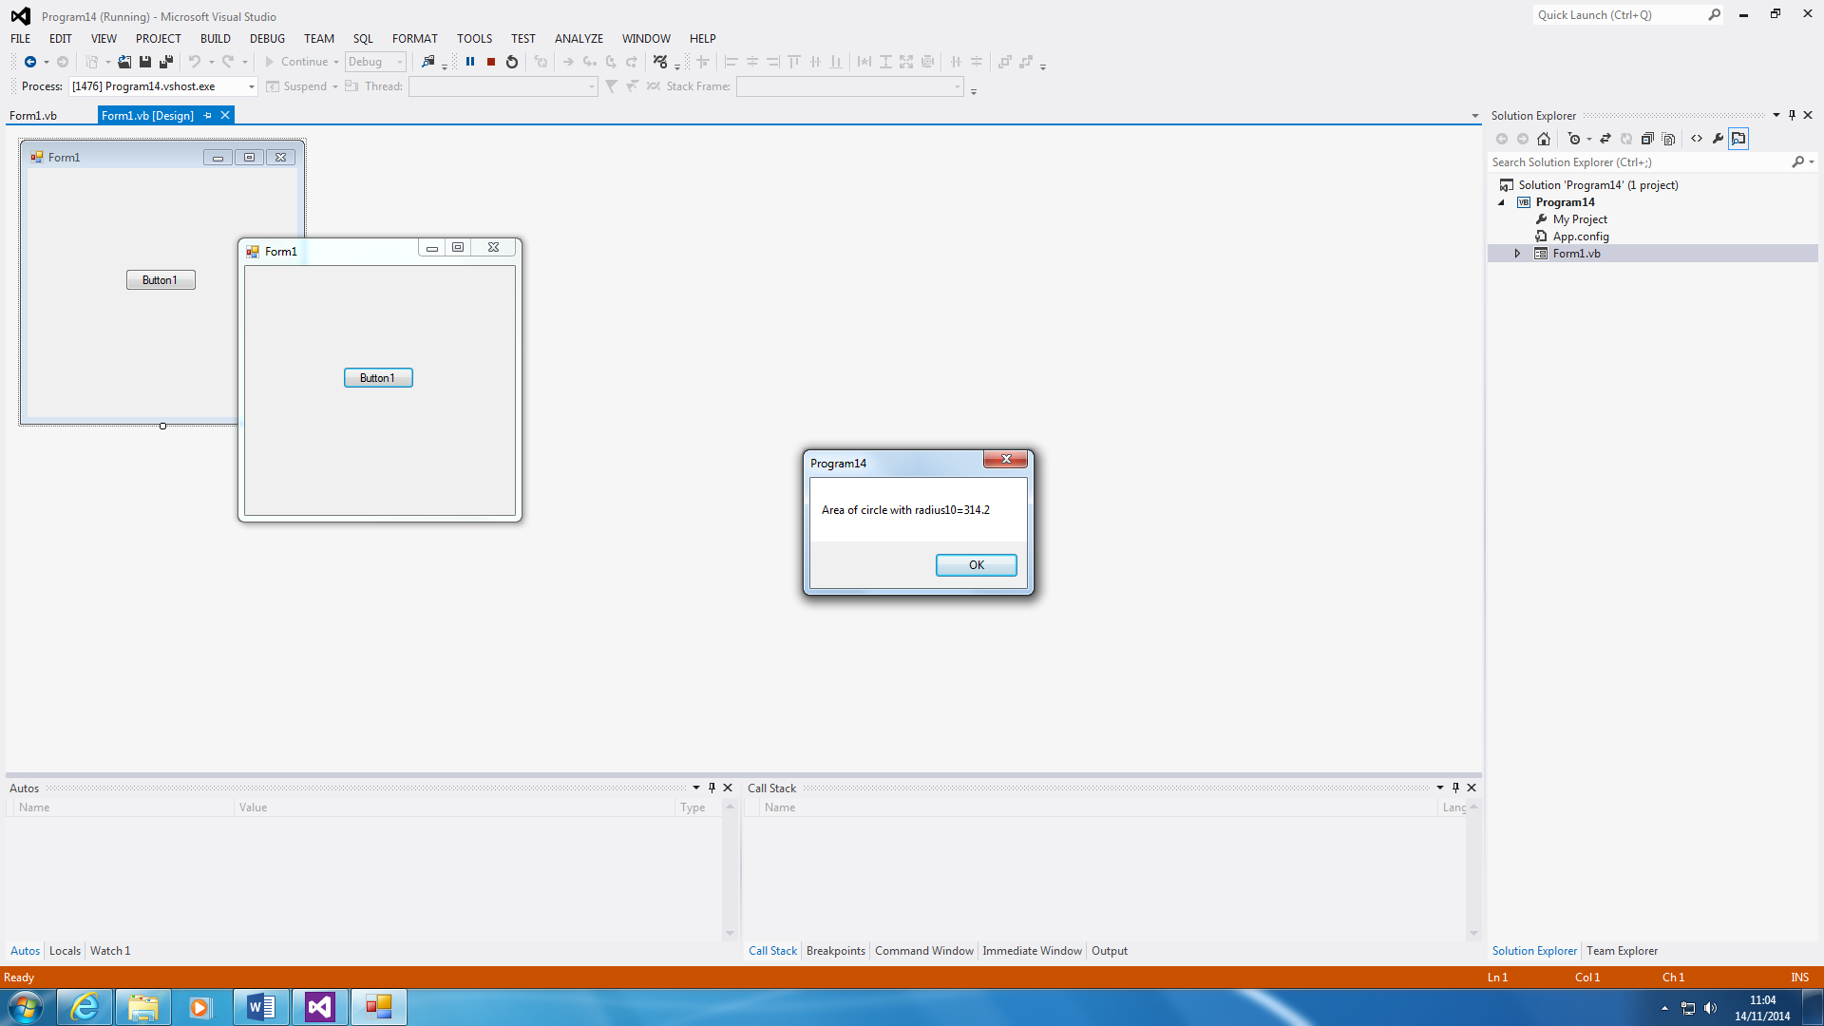

This seems simple, but it has been declared differently. Constant and Dim is the same, as in both are two declaring something, but they are used differently. Constant is used to declare a value that is very long e.g.3.14159265F. This is long, and it will take up space. You can just declare it by using Const. In this case, PI and R is used. PI is used for the π and R is used for Radius. The main aim is to find the area of the circle with the radius being 10. It shows the answer and it is 314.2.

**Program 15 – LOAD**

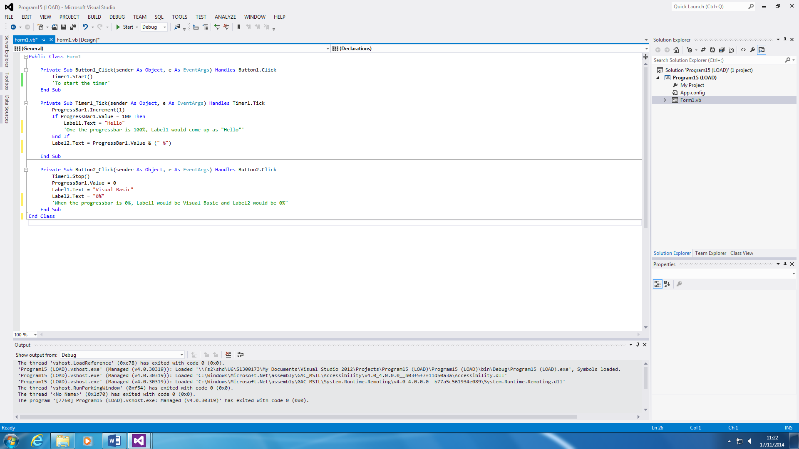

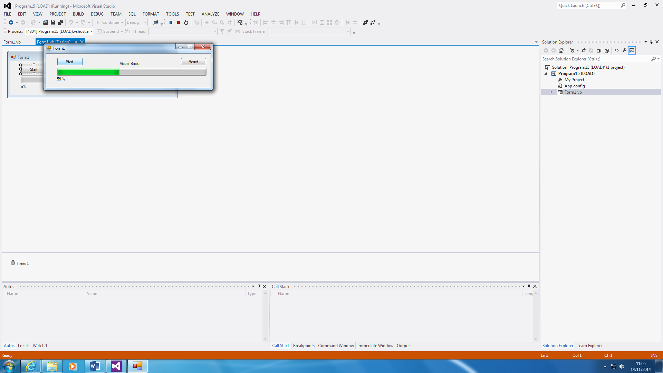

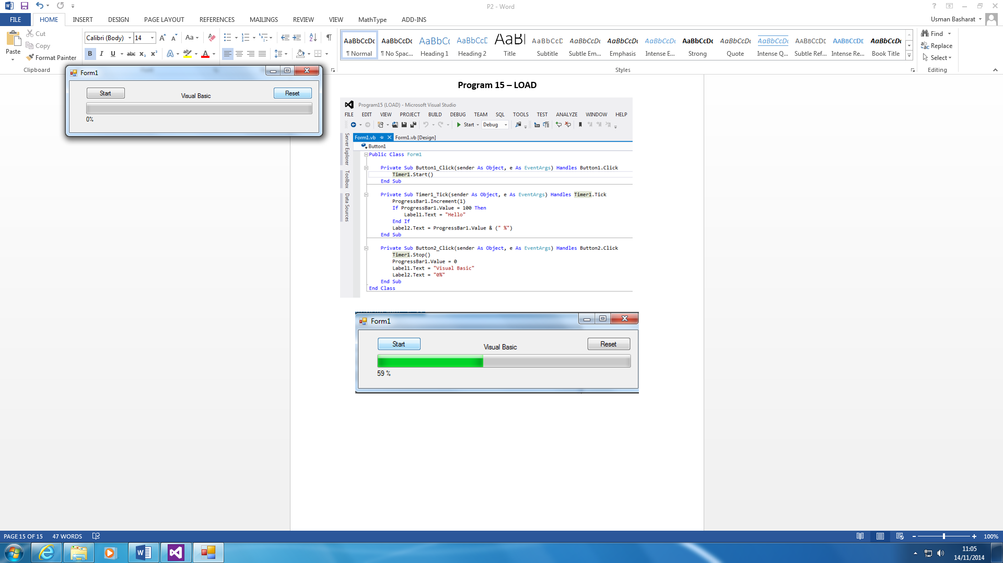

This program is designed to specifically show that a progress bar is loading. As you can see, the progress bar is 0%, and as soon as it has been pressed, it goes to 100%. Once it has been done, you can reset it by clicking on the ‘reset’ button. This is all it does. You can also change how fast the ‘green line’ will go to a 100. I went on its properties and changed it from 100 to 20.

**Program 16 – CASE Tools**

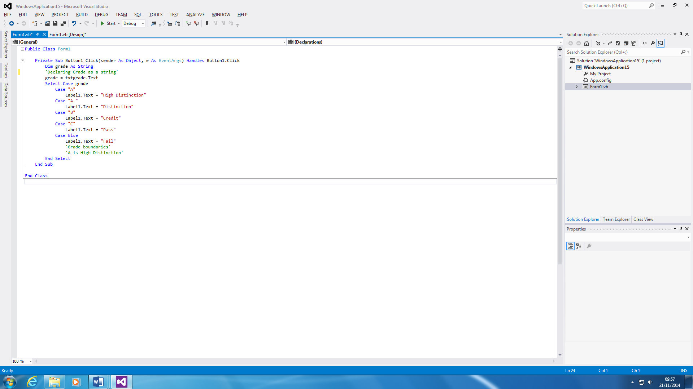

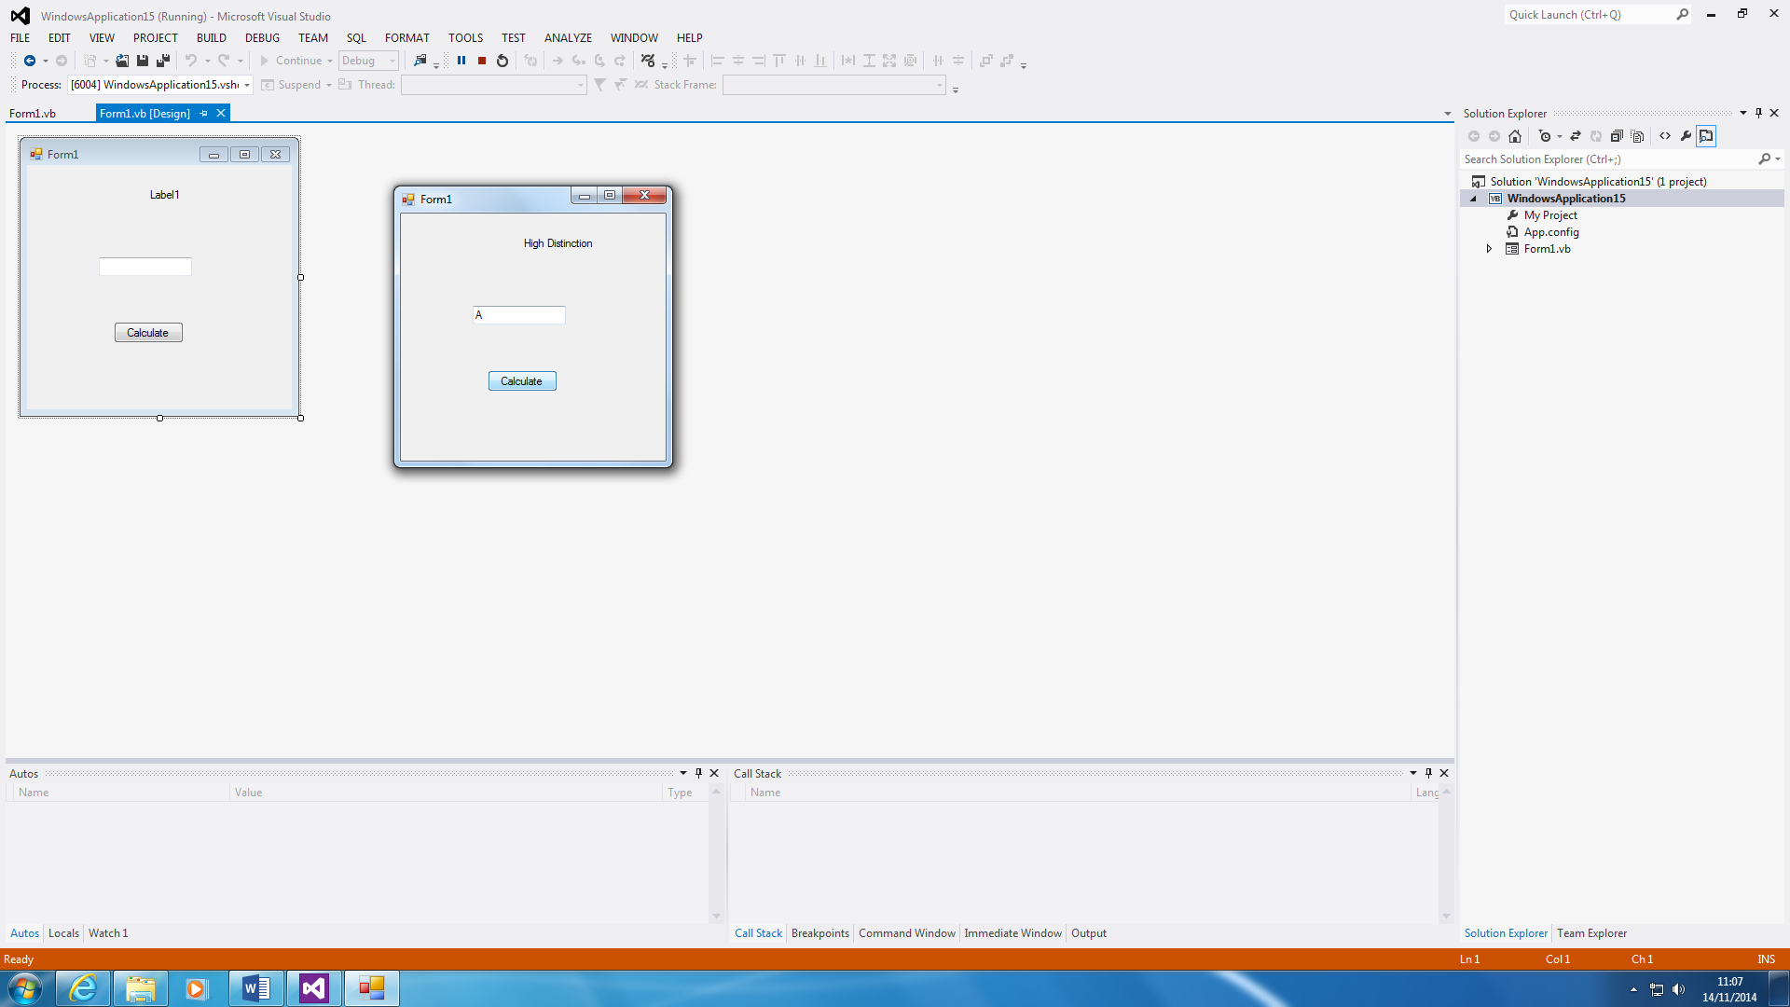

This is a program that shows how to convert a grade. For example, if I got grade A, and the teacher told me that you need to convert it, you can use this program to tell you that the grade is High Distinction. This has a variety of it.

A = Distinction

B = Credit

C = Pass

If anything else, it would be FAIL.

**Program 17 – DO WHILE**

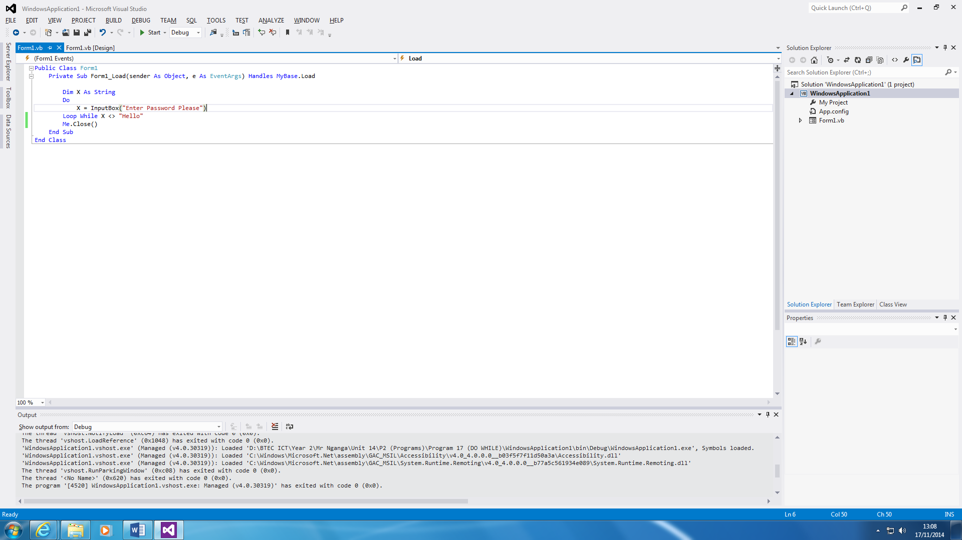

This program is similar to the other program that is made, but it has a ‘DO WHILE’ loop right at the end of it. This is a password program, and you have to type in a specific-coded password for you to release. The password is ‘Hello’, and the user can only continue if the password, ‘Hello’ has been entered. You cannot move, or close the screen until it has been complete.

‘Me.Close ()’ tells us that once the password has been entered, it close the application. This show us you can only type in the password, and it is complete.

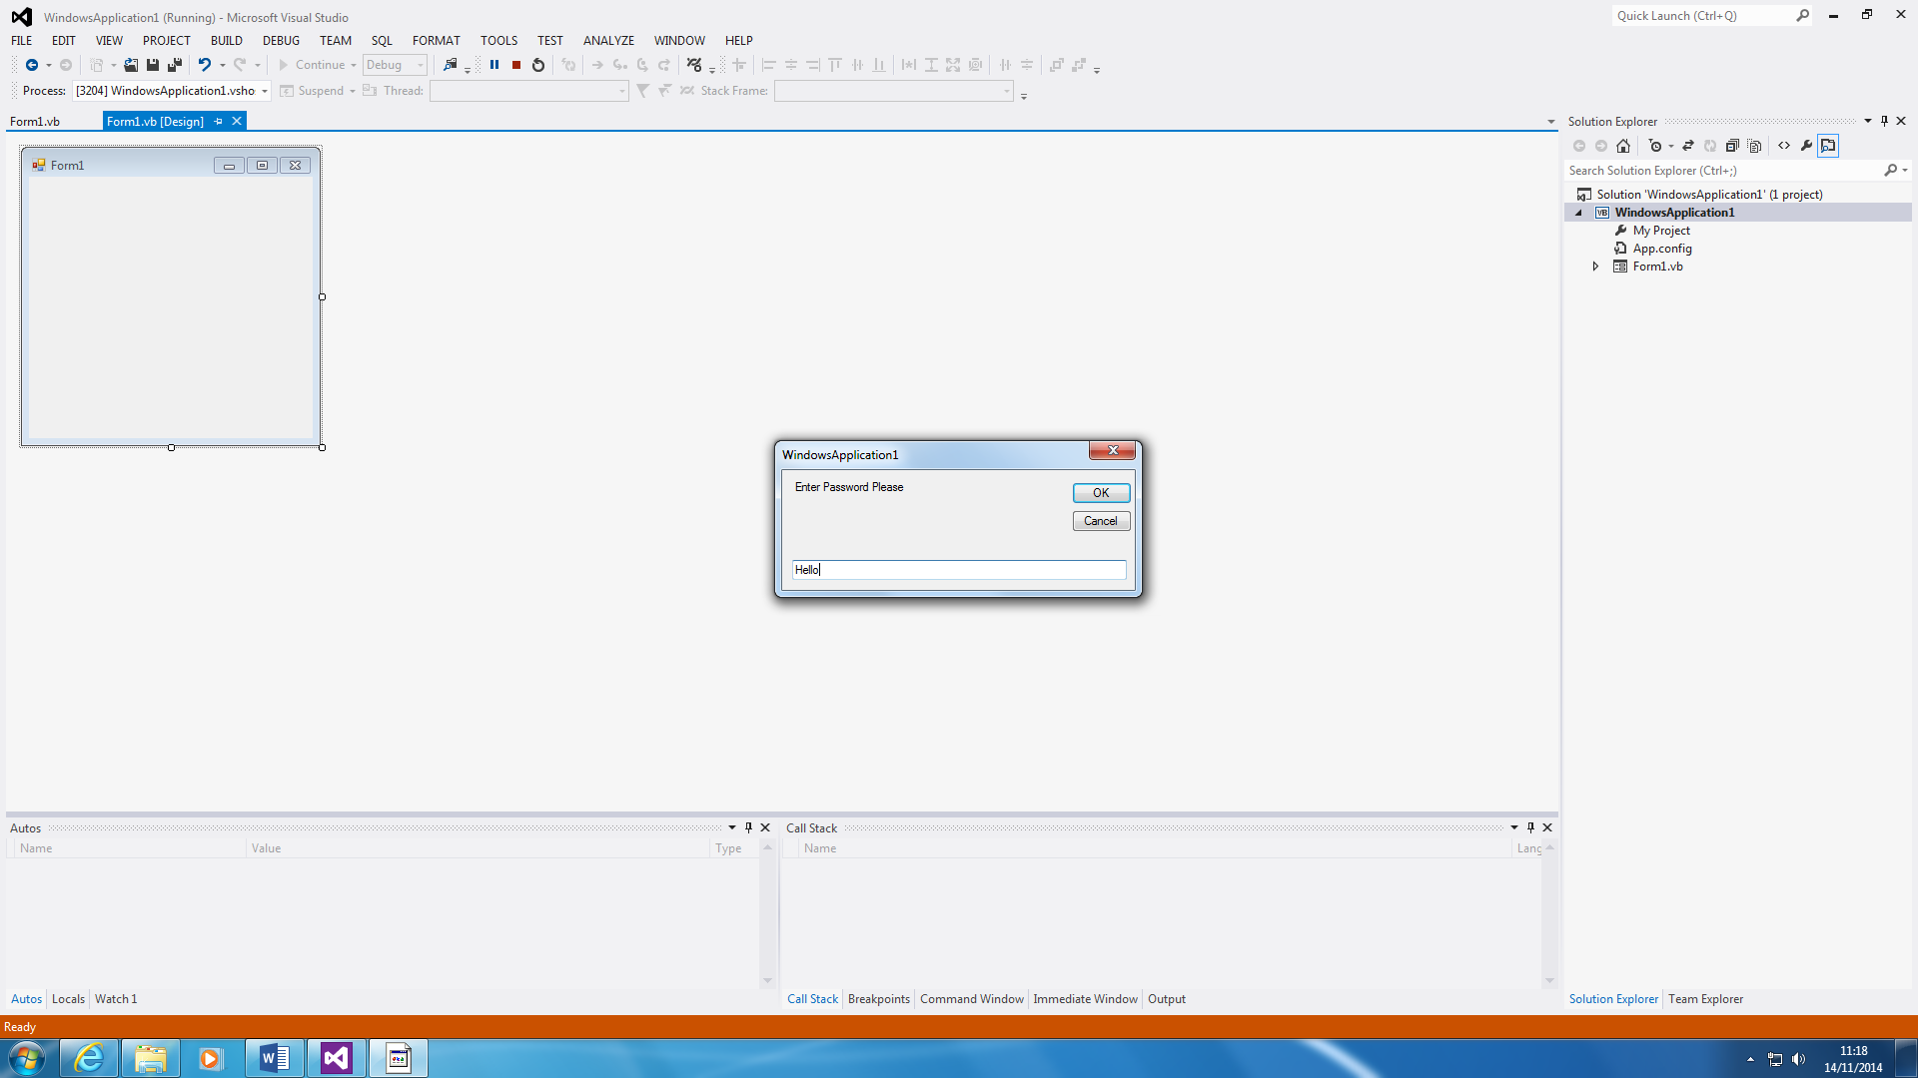

**Program 18 – SCOPE**

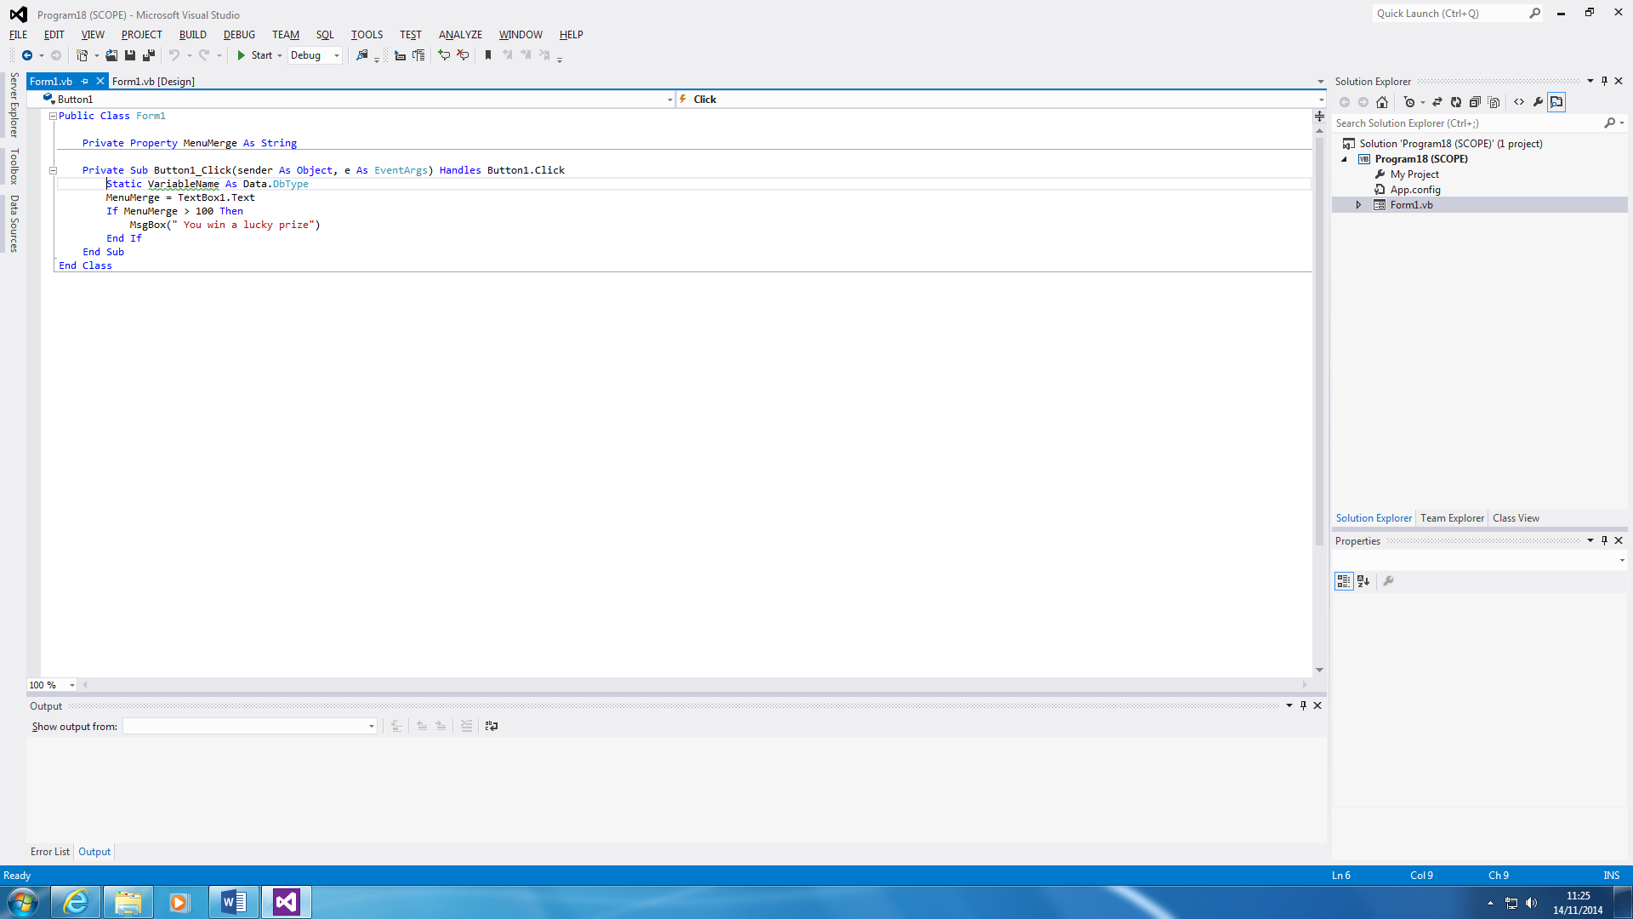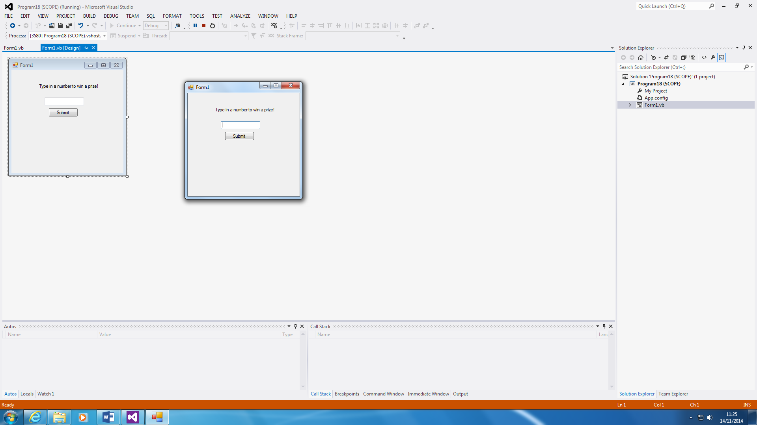

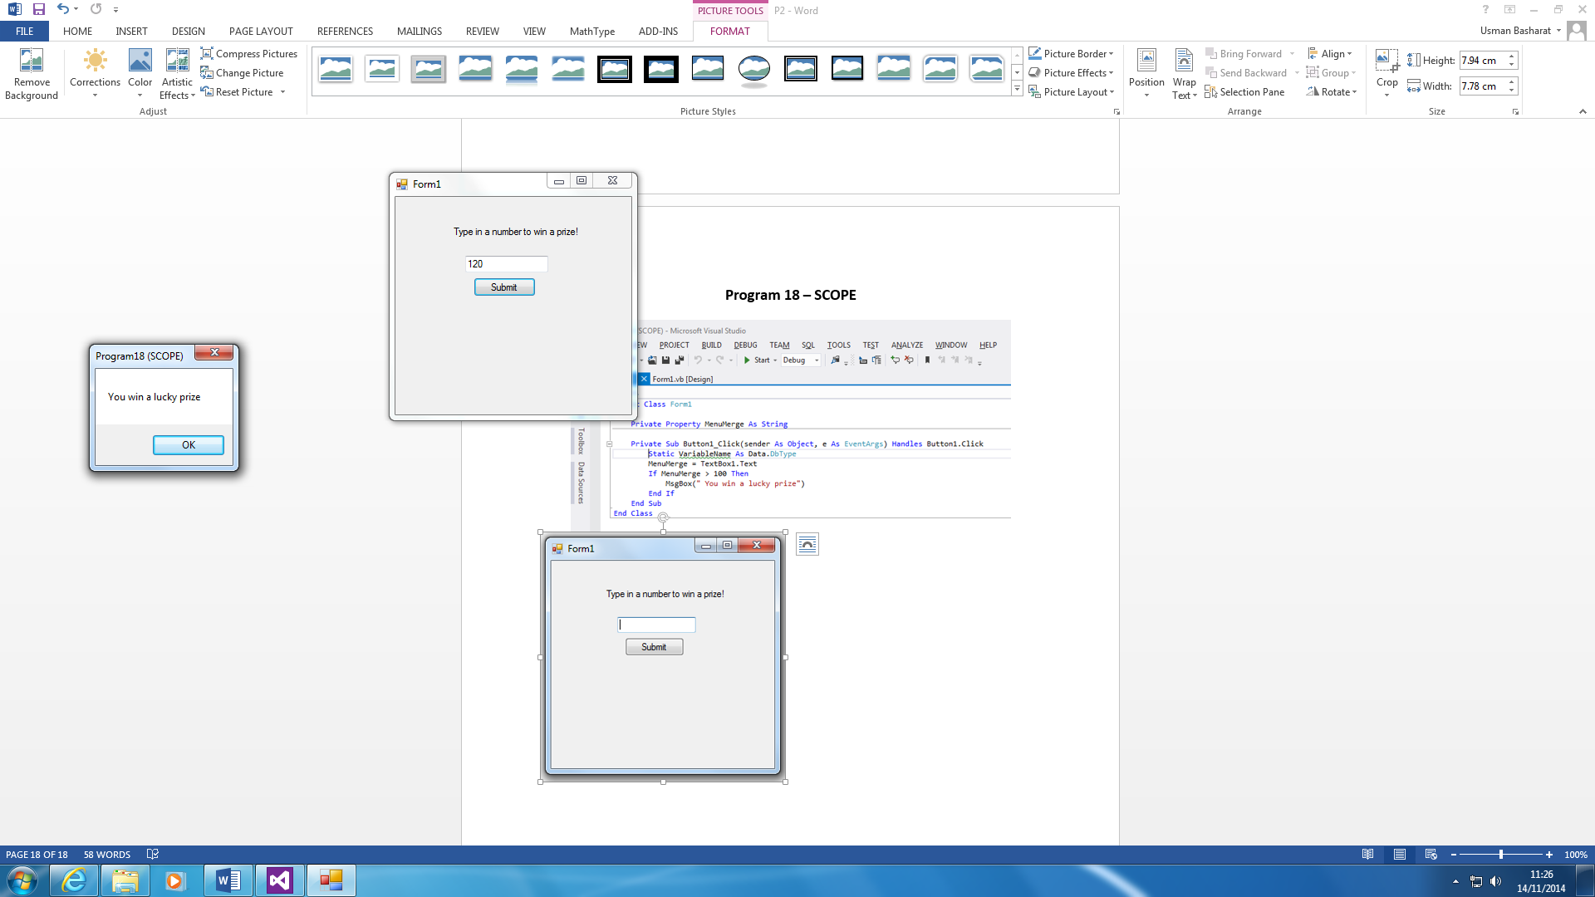

This is a program that is verified by ‘static’ and it is a type of datatype. As you can see, the program is explained and the number has to be above 100 for the user to get a lucky prize. This program could be used for a specific competition. All you can do is change the IF statement to whatever you want the number to be typed in. This is for the user to win a lucky prize. This is verified by Statics, and this verifies it the variable name.

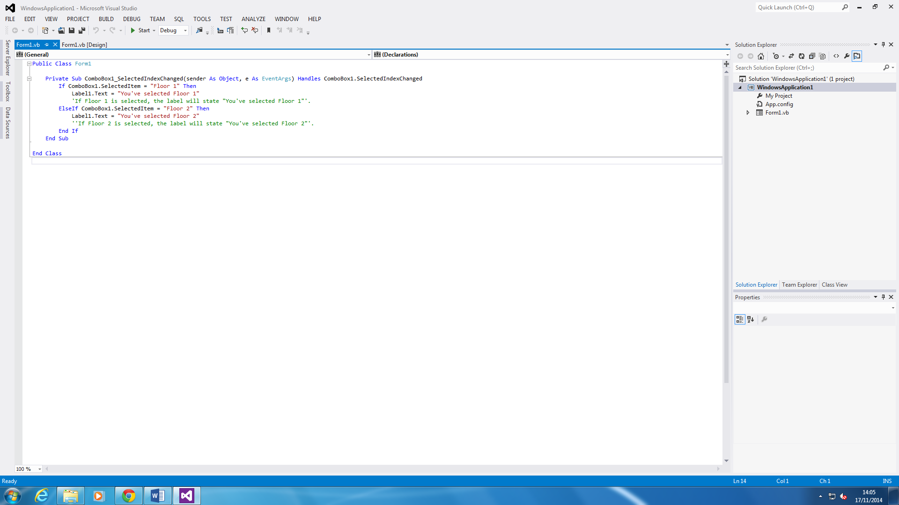**Program 19 – Drop down box**

This is a use of drop-down box. The options on the drop-down is to choose which floor you want. As soon as you have chosen either of them, the label will appear a message as ‘You’ve selected Floor 1 or Floor 2. This is all it does, but the main aim is to focus on the drop down box. It gives you options.

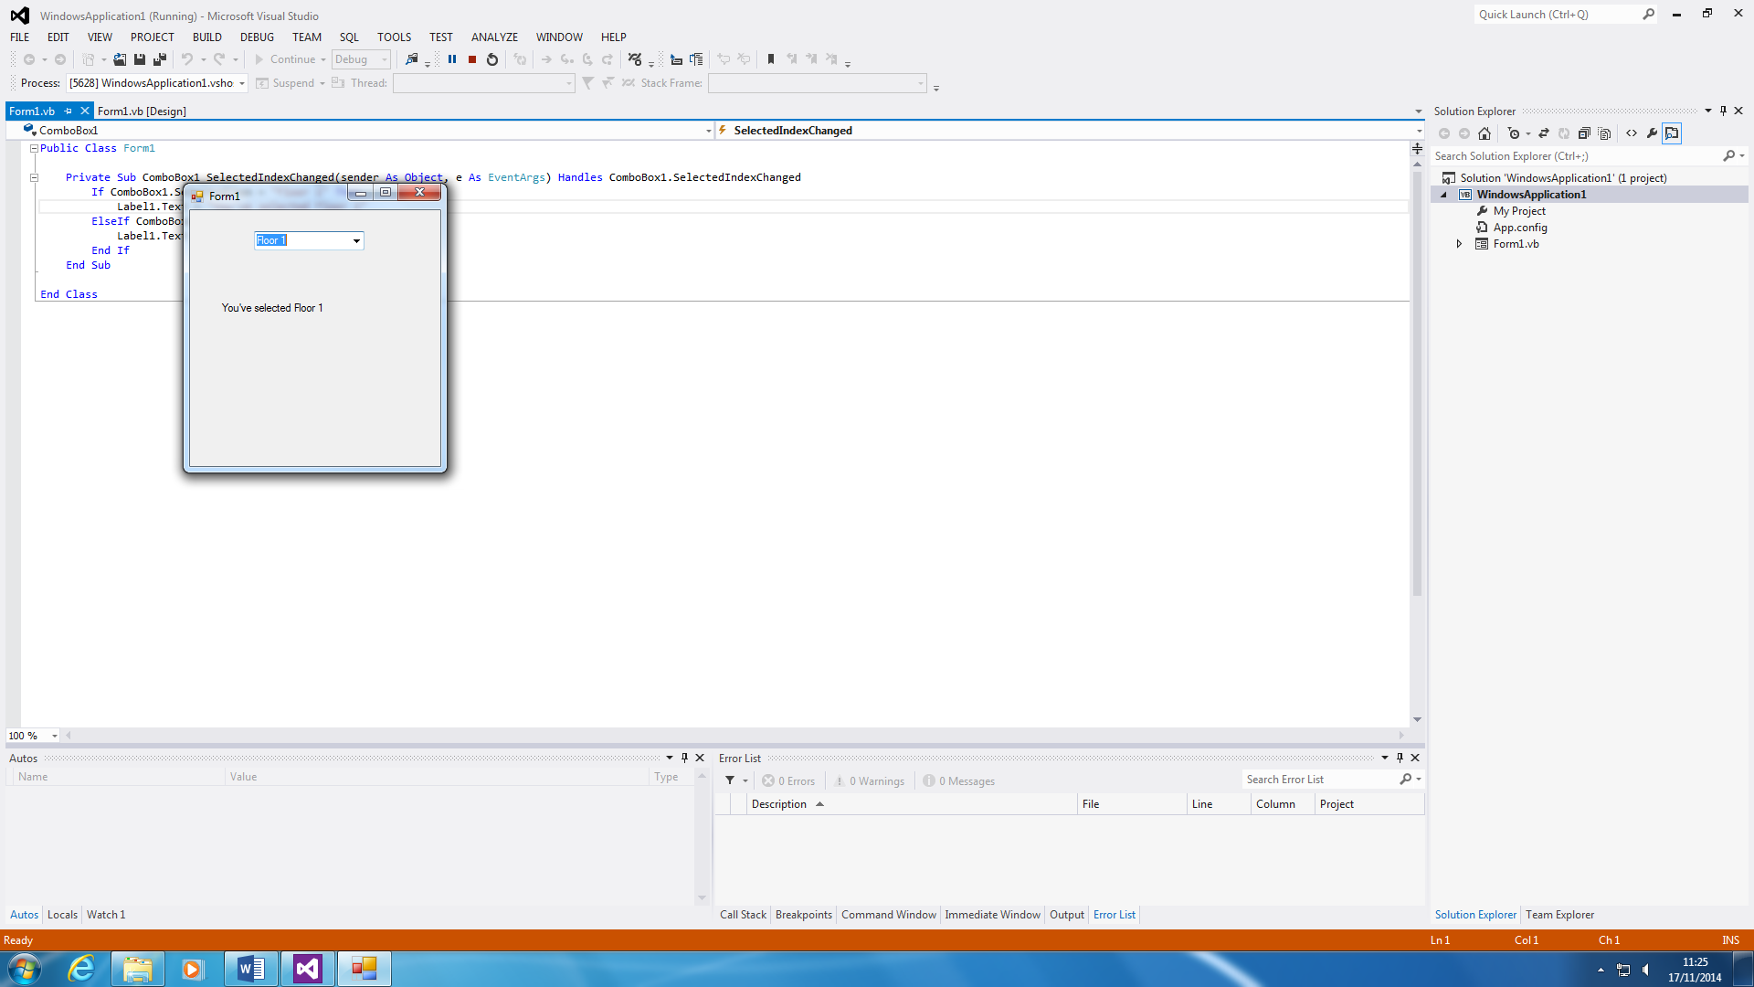

**Debugging**

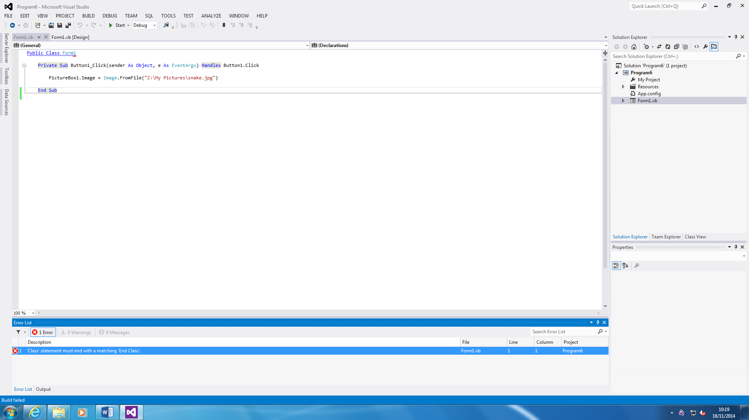

This is the debugging tool. Any errors that you have within the program, will appear within the Error List. First of all, the error that is says is the statement must end in ‘End Class’. If this is not inserted, the program cannot be started. If any errors that confuses you i.e. you do not understand what to do, you double click on it and it automatically directs to what the error is. For this, all I did is add ‘End Class’ and there was no more errors within the system.

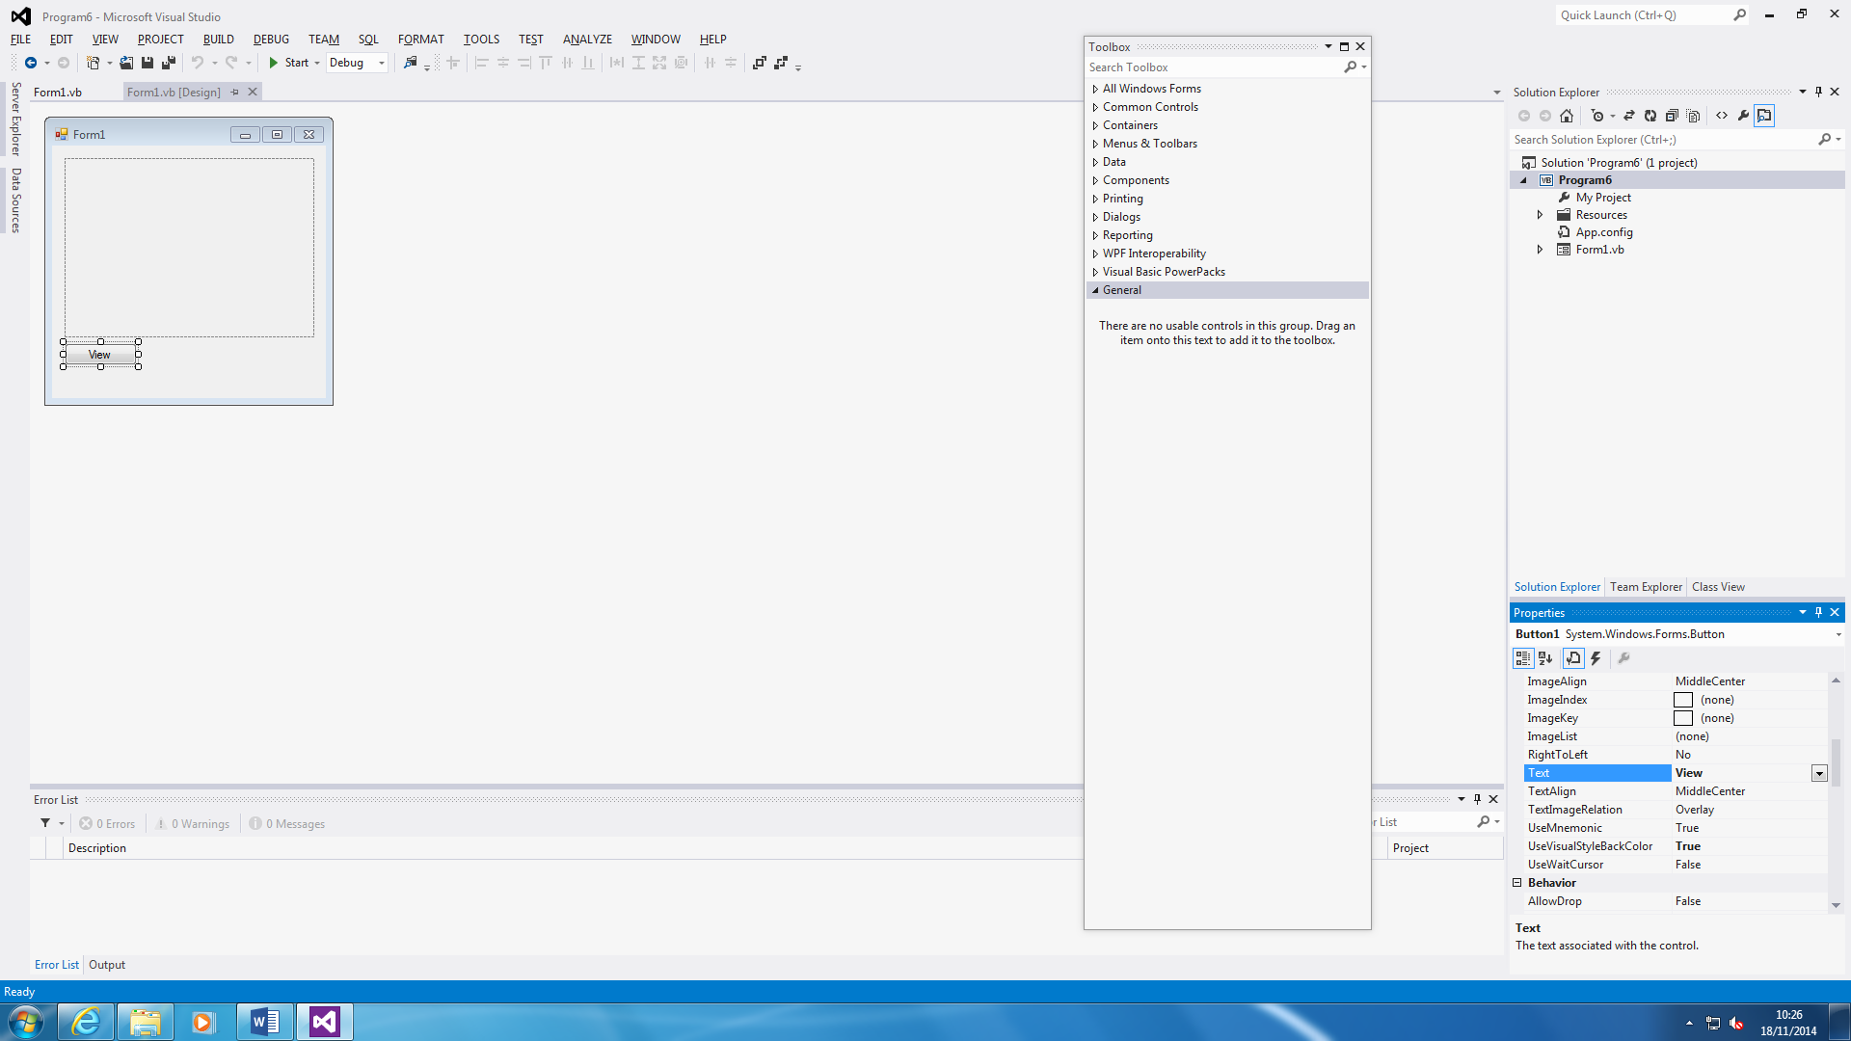**Properties**

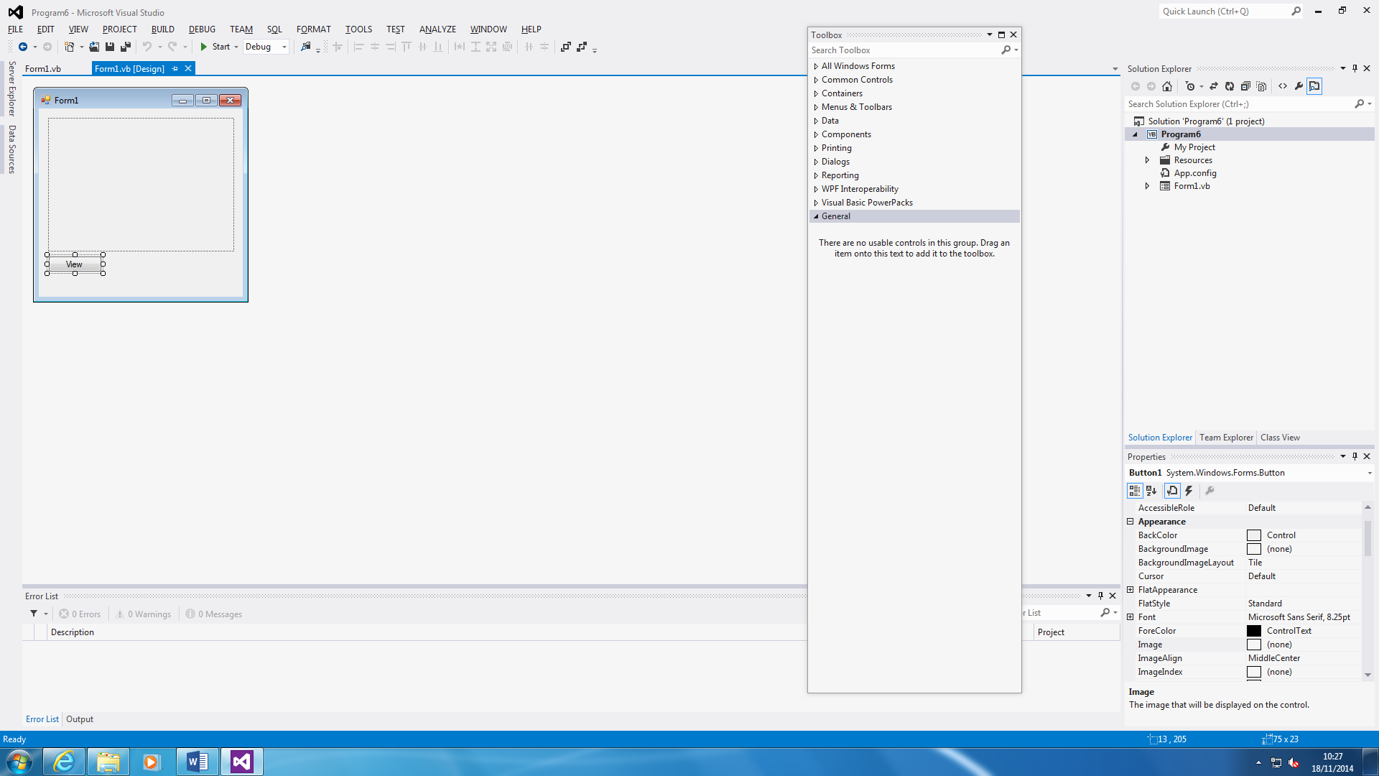

This is what I have used to for the properties. As an example, all you do is change the properties of the text. Before it was ‘Button1’ and I changed it to ‘View’ to make it realistic to what I have done for the program. You can change it to whatever text you feel like e.g. Submit or Close.

**Toolbox**

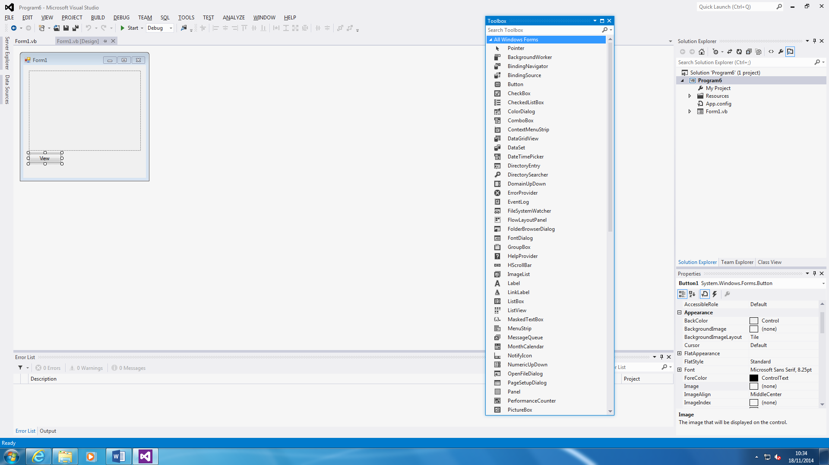

This is a Toolbox. You go there to find any tools you need to insert within your program. I have used button, progressbar, label, listbox, picturebox, textbox, and timer.